**Modeling Total Water Level and Associated Flood Areas Under the Impact of Climate Change and Hurricane Activity**

**Sensitivity of Water Level and Flood Area Prediction to Hurricane Characteristics and Climate Change Impacts**

**Ahmed Elkut1,*, Fengyan Shi1, Jack Puleo1**

**1,*Civil and Environmental Engineering Dep., University of Delaware, Newark, Delaware**

**Abstract**

The combined impact of hurricanes and climate change can significantly change the Total Water Level (TWL) leading to severe impacts on coastal zones such as flooding and erosion. Accurate prediction and evaluation of water levels are also needed to predict the impact on military readiness and resilience for coastal facilities. This study evaluates the efficiency of water level and flood area prediction using D-Flow FM under the impact of climate change and hurricane activity with application to the Naval Station Norfolk (NSN), Virginia, USA.

The water level (tide and surge) was simulated and the potential flooding resulting from historical hurricanes (Irene, and Isabel) at NSN was evaluated. The hurricane characteristics were obtained from the National Hurricane Center (NHC). The model was forced by a parametric wind force, the Holland Model that allows easy manipulation of hurricane parameters. The sensitivity of the simulated water level and flooding to various perturbations in the hurricane characteristics such as track, wind speed, atmospheric pressure, and radius of the maximum wind was evaluated. In addition, the projected climate change-induced relative sea level rise (SLR) was investigated and the potential impact on potential flooding was evaluated.

The results show that the D-Flow FM can accurately simulate the water level with an average correlation coefficient and RMSE of 97.4% and 0.17 m (less than 7% of the water level range) respectively. Some underestimations in the water level prediction were observed at some stations, with an average bias of -0.14 m, which might be attributed to the impact of river discharge and the wave-induced water level, which were not considered in this study. The flood areas were also predicted with a good level of accuracy when using appropriate mesh resolution that reflects a more accurate topographical representation. It was found that changes in hurricane’s wind speed and projected track can have significant impacts on the water level and projected flooding. In addition, climate change related SLR can substantially increase the severity of flooding and lead to inundation. Significant parts of the NSN base were found to be vulnerable to flooding under the considered scenarios, with flood areas ranging from 0.28km2 to ~5.94km2 (~1.3% - ~43% of the total NSN area), with the largest predicted flooding for the SLR scenarios.

# Introduction

Total water levels (TWL) consist of the mean sea level, tide, storm surge, and wave-induced setup and runup. Although the changes in tidal magnitude are conservative, changes in the non-tidal components are highly affected by the dominant meteorological forcing (e.g. wind and atmospheric pressure) and climate change. Extreme weather events such as hurricanes can significantly impact TWL, while climate change can significantly increase the mean sea level.

Storm surges are one of the most significant natural hazards and dominant drivers of coastal flooding, leading to loss of human life, destruction of homes and civil infrastructure, and disruption of industry and coastal military facilities (Hanson et al., 2011; Hinkel et al., 2014; Resio & Westerink, 2008). Meteorological events (e.g., hurricanes) tend to produce wind-driven storm surges and intense precipitation at the coast causing significant increases in the total water level (TWL) that often lead to severe coastal flooding, (Tang & Gallien, 2023).

In the United States over half of the U.S. population inhabits the coastal regions (Moftakhari et al., 2015). Based on the National Oceanic and Atmospheric Administration (NOAA), 2023, severe storms, tropical cyclones, and flooding have caused 144 deaths and cost more than 71 billion dollars only during 2023. In addition, it was reported that the distribution of damage from U.S. Billion-dollar disaster events from 1980 to 2023 is dominated by tropical cyclone losses, with the highest average event cost of ~$22 billion per event, [**https://www.ncei.noaa.gov/access/billions/**](https://www.ncei.noaa.gov/access/billions/). The North-Atlantic coasts of the U.S. are vulnerable to coastal flooding caused by extreme weather events such as Nor’easters and hurricanes during the Atlantic hurricane season (Muis et al., 2019; Wahl et al., 2015). Coastal military facilities are among the most sensitive and valuable areas along the US coast that are vulnerable to coastal flooding under the combined impacts of hurricanes and climate change.

An increase in climate change-related sea level is expected to exacerbate storm-surge-related risks to coastal communities because the frequency and extent of coastal flooding are likely to increase (Vitousek et al., 2017). In addition, the impacts of a storm surge may further intensify when it coincides with a high spring tide. Climate change-related Sea Level Rise (SLR) is a clear and present risk to the United States, now and for the foreseeable future. Relative Sea Level (RSL) along the contiguous U.S. (CONUS) coastline is expected to rise, on average, as much over the next 30 years (0.25–0.30 m over 2020–2050). These estimates go up to more than 2.2 m in 2100 and 3.9 m in 2150 (relative to sea level in 2000) considering the high emission scenario,(Sweet et al., 2022). Such an increase in mean sea level can significantly enhance the severity of tropical cyclones and hurricanes causing more intensified and frequent coastal flooding of coastal zones, (Ghanbari et al., 2021; Muis et al., 2023; Tanoue et al., 2016). In addition, according to (Taherkhani et al., 2020), the probability of extreme flooding might double approximately every 5-10 years.

Therefore, Accurate prediction of TWL for extreme events is crucial to predict the potential impact on coastal zones and military readiness & resilience for coastal facilities, (GAO, 2019; Hall et al., 2016; UOCS, 2016). In addition, it will help support stakeholders and federal agencies in adequate planning, prompt flood emergency response, and flood risk management decisions.

Various techniques are used for coastal flood prediction including static (bathtub) and dynamic methods. The static method assumes that areas lower than a certain extreme water level are inundated if there is hydrological connectivity. Such a technique was commonly used, in a GIS environment, because the physics-based sophisticated models were challenging to employ, especially in the absence of appropriate computational power. However, the resulting flood maps, of this method, were known to generally overestimate the flood extent due to the omission of important factors influencing floodwater flow such as bottom friction, the conservation of mass, and flood duration, (Kumbier et al., 2018a)**.**

On the other hand, the dynamic modeling approach utilizes sophisticated hydrodynamic models (e.g. D-Flow FM, ADCIRC, and 2D HEC-RAS) to simulate the flow of floodwater resulting from various sources such as tides, surges, wave-induced water level, precipitation, and riverine discharges. These models have been applied successfully in coastal flood risk assessments at different scales and with varying degrees of model complexity (Bakhtyar et al., 2020; Bilskie & Hagen, 2018; Ke et al., 2019; David F. Muñoz et al., 2022; Sebastian et al., 2014). Considering the potential flooding drivers that hydrodynamic models can account for, they are the more appropriate tool for assessing the extent and depth of flooding resulting from coastal flood events.

Most coastal flooding studies focused on the impacts of marine water levels (often storm-surge-dominated) and fluvial or pluvial flows, (Ghanbari et al., 2021; Ke et al., 2019; Kumbier et al., 2018; Nederhoff et al., 2021), or compared the performance of different hydrodynamic models in water level and ground flood prediction (Bakhtyar et al., 2020; David F. Muñoz et al., 2022). However, uncertainties and inaccuracies in the hurricane characteristics, hence hydrodynamic models’ input, (e.g. Pressure drop, radius of maximum wind and track) and accurate representation of the topography and bathymetry, (D. F. Muñoz et al., 2020)**,** are often understudied. In addition, taking climate change-related impacts (e.g. sea level rise and changes in wind speed) into account is not widely investigated.

This study aims to evaluate the sensitivity of water level and associated flood prediction, under hurricane activity, to the impact of climate change and perturbations in hurricane characteristics. The sensitivity to the lack of inaccurate input data was also assessed. In order to enhance military installation readiness and resilience, an application to the US Naval Station Norfolk, Virginia was carried out.

For that purpose, the state-of-the-art D-Flow FM (D-Hydro) hydrodynamic model was used. The performance of D-Flow FM in water level prediction was evaluated in previous studies against ADCIRC (Bakhtyar et al., 2020) and 2D HEC-RAS, (David F. Muñoz et al., 2022), where they found that the D-Flow FM can accurately predict the water level, taking into account the accurate representations of the wind input and the bottom roughness.

To address our aim, several objectives were addressed as follows:

1. Predict the WL during Hurricane Irene 2011 and Hurricane Isabel 2003 and quantify the model skill in predicting the timing, magnitude, and duration of the peak surge using available water level station data.
2. Identify flooded spatial area as a function of time and flooded depth and compare the results to available anecdotal data.
3. Evaluate the sensitivity of the model predictions to the impacts of climate change and changes in meteorological forcing, such as central pressure drop (PD) and radius of maximum wind (RMW).
4. Conduct “degradation simulations” to the baseline simulations to quantify the prediction error when there is a deficit of information (resolution and accuracy). These simulations provide critical information on prediction confidence when input and forcing data are imperfect (always the case in a predictive scenario).

## Site description

The City of Norfolk includes more than 200 miles of riverfront and bayfront land, including beaches along Chesapeake Bay, and is surrounded by numerous bodies of water. Norfolk is prone to flooding, much like other low-lying coastal areas, because of its elevation and proximity to natural waterways, particularly during times of heavy rain, hurricanes, or nor'easters. Precipitation flooding poses a threat to properties across the city during these occurrences, and properties close to natural waterways are particularly vulnerable to tidal inundation and wind-driven floods.

Norfolk is located on the south shore of the Chesapeake Bay approximately 30 km west of the Atlantic Ocean in southeastern Virginia (USA), Figure 1. The city has a population of approximately 250,000 people and is home to an active military facility (Naval Station Norfolk). With most of its elevation within 5 m of mean sea level (MSL), the city is highly vulnerable to the impacts of SLR, nuisance flooding at high tides, and surges during tropical and extratropical storms.

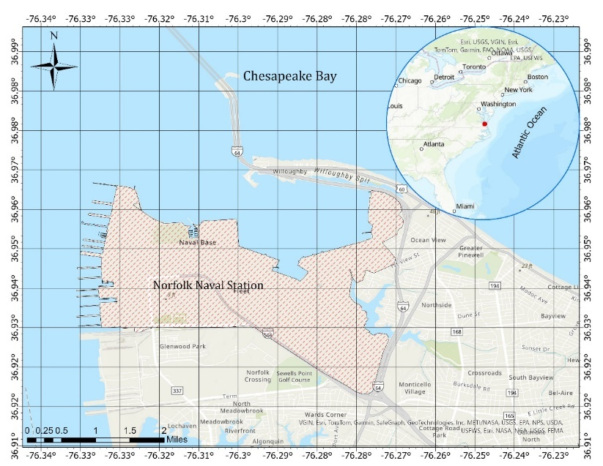

Figure 1. Thematic map showing Naval Station Norfolk (shaded area) with an overview map that shows the study site location (red dot) relative to the wider US east coast.

The area has a mean tidal range of 0.74 m and typically experiences an east-south-easterly wind-wave climate with significant wave heights of 0.4 m and peak periods of 5s (averaged over data from 2006 to 2021). The coastline is characterized by average beach and surf zone (wave breaking region) slopes of 1:30 and 1:40, respectively; where the beach is defined as the region ±2σ around the mean shoreline elevation (setup), σ is the standard deviation of the continuous water level record, and the surf zone is defined as the area between the setup location and the location of wave breaking.

In August 2011, during Hurricane Irene, the city experienced significant flooding and damage on the order of USD 12 million. Just offshore of Norfolk, the hurricane brought combined tide and surge levels of up to 1.89 m above MSL, maximum wind speeds of 27 m/s, and significant wave heights of up to 2.62 m.

The city of Norfolk hosts one of the largest naval stations in the country, Naval Station Norfolk (NSN). This station was chosen to provide an end member of a geomorphological setting and hydrodynamic forcing. The geomorphological setting with a wide continental shelf would suggest that waves may have less importance than surges. Similarly, NSN experiences hurricane forcing and possible Extratropical Storms (ETS) forcing at different times of the year making it a suitable location to test model capability under these varied forcing scenarios.

# Approach/Methods

This study is executed in three main stages. Initially, the water level (Tide and Surge) and associated flooding were simulated and the potential flooding resulting from historical hurricanes (Irene and Isabel) was evaluated at NSN. For that purpose, the D-Flow FM, (Deltares, 2023) model was used. D-Flow FM has been efficiently used in complex coastal flood modeling applications (Kumbier et al., 2018b; D. F. Muñoz et al., 2020b; David F. Muñoz et al., 2022b; Nederhoff et al., 2021b). The hurricane characteristics were obtained from the National Hurricane Center (NHC). Thereafter, the sensitivity of the modeled water level and flooding to various perturbations in the hurricane characteristics (e.g. track, wind speed, pressure drop, and radius of maximum wind) were evaluated. In addition, the projected climate change-induced relative sea level rise (SLR), according to (Sweet et al., 2022) for Intermediate-Low scenarios for the US East Coast: 0.4m, 0.8m, 1.3m, projected for years 2050, 2100 and 2150 respectively, were included. Finally, a number of degradation scenarios were conducted to evaluate model performance when there is a deficit of accurate input data. These degradation scenarios included bathymetry error, mesh resolution, and potential error in the hurricane track.

## Model Setup (D-Flow FM)

Delft3D-FM is an open-source flexible integrated modeling suite, that simulates one-dimensional (1D), two-dimensional (2D; in either the horizontal or a vertical plane), and three-dimensional (3D) flow, sediment transport and morphology, waves, water quality, and ecology and can handle the interactions between these processes. The Delft3D Flexible Mesh Suite (Delft3D FM) is the successor of the structured Delft3D 4 Suite, and it is developed and maintained by Deltares Netherlands as open-source software ([www.deltares.nl](http://www.deltares.nl) ).

Delft3D FM modeling suite is mostly used for the modeling of natural environments like coastal, river, and estuarine areas, but it is equally suitable for more artificial environments like harbors and locks. Delft3D FM consists of several well-tested and validated integrated modules, including D-Flow, D-Hydrology, D-Waves, and D-Morphology. In this demonstration, the D-Flow FM is used to simulate the interaction between the hurricane-induced wind, currents, and surges.

### Network

The computational network/mesh was created using the D-Flow FM Graphical User Interface (GUI) using a spherical coordinate system. The mesh has both rectilinear and triangular components with a resolution that extends from ~4km at the offshore boundary to ~15m at the NSN base. The mesh has a spatial extent of about 700km in the south-north direction and an average of 480km in the offshore direction. The refinement procedure of the mesh followed the degradation in the bathymetric contours to have high accuracy in the nearshore-shallower waters while maintaining a reasonable computational time.

### Bathymetry

Numerous data sources with different resolutions and accuracies were used to accurately represent the bathymetry and topography of the study area. These data include the Continuously Updated Digital Elevation Model (CUDEM), <https://coast.noaa.gov-/dataviewer/#/lidar/search/where:ID=8483/details/8483>, with a horizontal resolution of 1m and vertical accuracy of about 0.5m, National Center for Environmental Information (NCEI) Coastal Relief Model (CRM), <https://www.ncei.noaa.gov/products/coastal-relief-model>

, with a horizontal resolution of 90m and vertical accuracy of about 1m and the General Bathymetric Chart for the Oceans (GEBCO)-v2019, <https://www.gebco.net/data_and-_products/gridded_-bathymetry_data/>, which has a horizontal resolution of 450m with unknown vertical accuracy. All these data sources were combined and interpolated using the triangulation method using the D-Flow FM GUI. The higher-resolution data was used at the nearshore areas, whereas the lower-resolution was used at the offshore locations. Figure 2 shows the interpolated bathymetry for the D-Flow FM computational domain.



Figure 2. D-Flow FM bathymetry for the NSN base in the surrounding area with the overall model domain (inset map) of the US East Coast.

### Open boundary conditions

The model has three open boundaries, north, east, and south boundaries. The model was forced by two types of data along these boundaries. Tidal forces were employed as astronomical tidal components obtained from the TPXO8 global tidal model using the Delft dashboard toolbox. Two additional components were also added to the tidal forces which are solar annual (SA) and solar semi-annual (SSA).

In addition to the tidal forces, the baroclinic changes in the water level were mimicked using the E.U. Copernicus Marine Environment Monitoring Service (CMEMS). Modeling baroclinic water levels usually requires 3D modeling that considers the vertical layering of the water column to account for the density differences due to changes in temperature and salinity, which should be considered in the model as well, however, in this study we only used 2D depth-averaged model simulations. The CMEMS data is semi-diurnal and is referenced to the Geoid model. The data was re-referenced to the mean sea level (MSL) before usage in the simulations.

### Meteorological forcing

A meteorological forcing that relies on a parameterized wind field and contains only the hurricane wind field forcing; referred to as the Holland model was used, (G. Holland, 2008; G. J. Holland, 1980; Greg J. Holland et al., 2010). Holland model winds can be obtained in real-time or for forecast purposes. It is easy to implement and perturb. In addition, it can be generated with a resolution as high as the computational domain resolution if required.

### Model Characteristics

The land-sea boundary was obtained from the OpenStreetMap database for the entire eastern American coast, <https://osmdata.openstreetmap.de/data/land-polygons.html>. The model computes the courant criteria at each timestep with an initial value of 0.7. All data was referenced to the MSL and the GMT zone. The model was allowed to run for a few days before the peak surge occurred as a spin-up period. A set of observation points were used along the US east coast for the calibration against the measurements.

# Results

## Model Calibration (Base scenarios)

Calibration for Hurricane Irene was performed at different stations along the United States East Coast, in the Chesapeake Bay, and in the Delaware Bay, Figure 3. Water level data was obtained at these stations from the National Oceanic and Atmospheric Administration (NOAA) website, <https://www.noaa.gov/>. The data has hourly time intervals and is referenced to the mean sea level (MSL). The calibration procedure was carried out for Hurricane Irene and the same calibration settings were used for Hurricane Isabel as well.

Different parameters were used during the calibration procedure of the model including the calibration of the tidal constituents (amplitude and phase). For that purpose, harmonic analysis was performed to separate the tidal water level from the non-tidal water level and the results were compared to the observed data for calibration. On the other hand, sensitivity analysis of the bed roughness (Manning coefficient) values was carried out. A range of (0.01 – 0.03) was used for the sensitivity analysis. The results show that a Manning coefficient of 0.015 gives the best model results. Sensitivity to the network resolution will be evaluated and discussed in a later section.

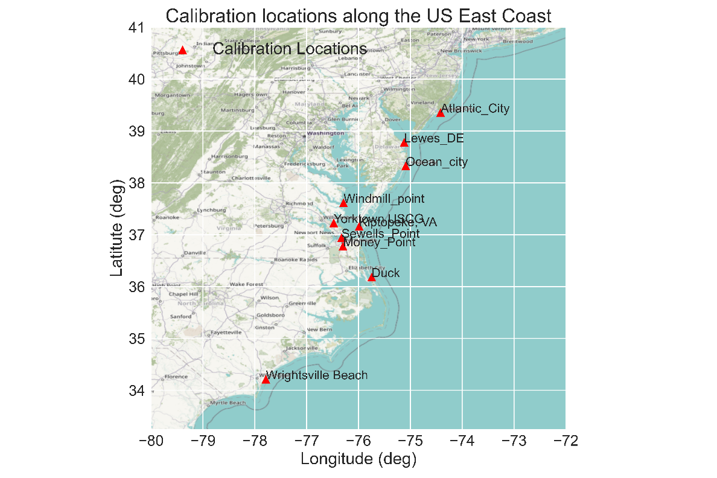

Figure 3. Calibration locations along the US East Coast

Figure 4 and Figure 5 show an example of the comparison between the measured and simulated water levels, at different locations from the 26th of August 2011 to the 30th of August 2011 (a few days around Hurricane Irene). High agreement was obtained between the simulated and measured water levels. The model can efficiently capture the peak surge with high accuracy. This is also evident in the distributions of the measured and simulated water levels which are highly comparable.

Statistically speaking, different error-measuring criteria were used to evaluate the skill of the model in water level prediction. Equations 1 to 3 show the formulae of these metrics.

**Correlation Coefficient: $R=\frac{\sum_{i=1}^{N}{(\left(P_{i}-\overline{P}\right)\left(M_{i}-\overline{M}\right))}}{\sqrt{\sum_{i=1}^{N}{{\left(P_{i}-\overline{P}\right)}^{2} (}}\sum_{i=1}^{N}{{{(M}_{i}-\overline{M})}^{2})}}$** (1)

**Root Mean Squared Error: $RMSE=\sqrt{\frac{1}{N}\sum_{i=1}^{N}{{\left(P_{i}-M_{i}\right)}^{2}}}$** (2)

$Bias= \sum_{i=1}^{N}{\frac{1}{N}\left(P_{i}-M_{i}\right) }$ (3)

Where $M_{i}$ is the measured value, $\overline{M}$ is the mean value of the measured data, $P_{i}$ is the predicted value, $\overline{P}$ is the mean value of the predicted data and N is the number of data points.

The model results show a high correlation with the measured data up to 99% with a Root Mean Square Error (RMSE) that ranges from 0.15m to 0.29m (<10% of the water level range). However, underestimations were also observed at some stations with a bias ranging between -0.04m and -0.2m for both hurricanes, Table 1. These underestimations might be attributed to other factors including fluvial and pluvial impact on the water level, which were not considered in this study. In addition, although it is assumed to have a minor contribution to the total water level at NSN, the wave-induced water level was not included in the calibration procedure as well. It is also worth mentioning that among the 9-calibration locations, some points are located far inside the rivers discharging into the Chesapeake Bay, or located very close to the shoreline where no accurate bathymetry exists. Finally, unlike Hurricane Irene, Hurricane Isabel approached the US east coast nearly perpendicular to the coast, approximately 200km south of the NSN base. Therefore, the best model performance was observed at the Duck location, which is the closest station to the eye/track of the hurricane. In addition, the model has a relatively good performance at locations at a large distance from the hurricane eye where the impact of the hurricane itself is minor and most of the water level there is tidal driven, e.g. Atlantic City, Figure *3*.

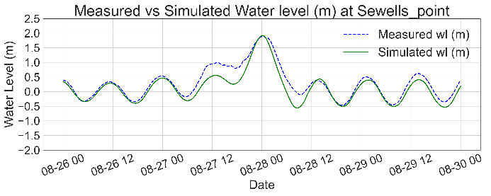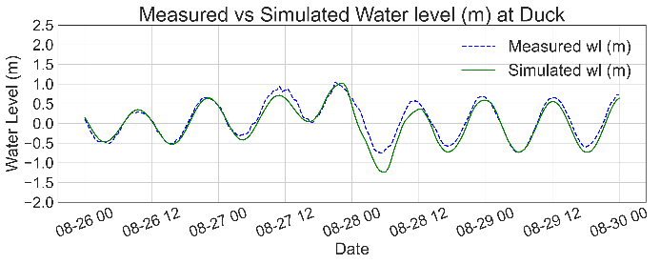

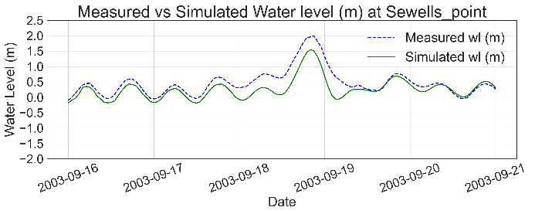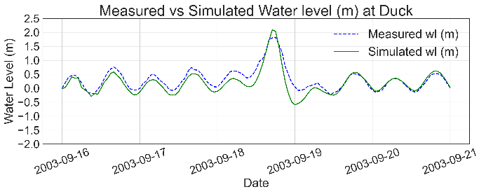

Figure 4. Measured vs Simulated water levels at different calibration locations during Hurricane Irene, 2011(upper panels) and Hurricane Isabel 2003 (lower panels).

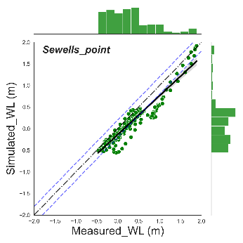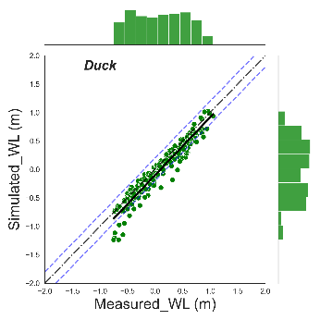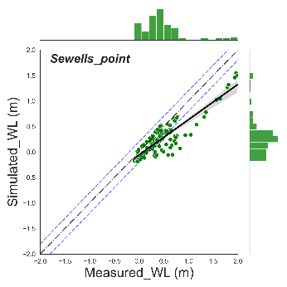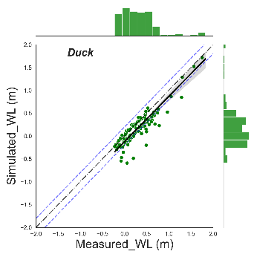

Figure 5. Scatter plots of the measured and simulated water levels (m) at Sewells Point and Duck for Hurricane Irene (left panels) and Hurricane Isabel (right panels). Histograms are plotted along the right and upper axes, NSN, US.

Table 1. Summary statistics of simulated and measured water levels at the different stations during hurricanes Irene and Isabel, NSN, US.

|  |  |  |  |  |  |  |  |  |
| --- | --- | --- | --- | --- | --- | --- | --- | --- |
| # | Location | Irene | | | | Isabel | | |
| R | RMSE | Bias | R | | RMSE | Bias |
| 1 | **Atlantic City** | 0.96 | 0.24 | -0.17 | 0.90 | | 0.15 | -0.04 |
| 2 | **Lewes DE** | 0.97 | 0.25 | -0.18 | 0.88 | | 0.22 | -0.13 |
| 3 | **Windmill Point** | 0.96 | 0.19 | -0.15 | 0.89 | | 0.15 | -0.10 |
| 4 | **Yorktown** | 0.95 | 0.22 | -0.15 | -- | | -- | -- |
| 5 | **Kiptopeke** | 0.97 | 0.16 | -0.11 | 0.88 | | 0.21 | -0.11 |
| 6 | **Sewells Point** | 0.95 | 0.23 | -0.17 | 0.88 | | 0.29 | -0.20 |
| 7 | **Money Point** | 0.94 | 0.27 | -0.18 | -- | | -- | -- |
| 8 | **Duck** | 0.96 | 0.17 | -0.10 | 0.92 | | 0.21 | -0.13 |
| 9 | **Wrightsville** | 0.96 | 0.20 | -0.05 | -- | | -- | -- |

The peak surge characteristics were evaluated based on three criteria, magnitude, duration, and timing. For peak surge magnitude and timing, a simple difference algorithm is applied to assess the skill of the model to predict these criteria. For duration, the surge was classified into three levels; Low: (0.5 - 1.0m), Medium: (1.0 – 1.5m), and High: (>1.5m). The duration of each surge level was calculated and compared to the measured data. All the calculated statistics were applied to Sewells Point only due to its proximity to the area of interest, Table 2. It is worth noting that model results at Sewells Point do not reflect the best model performance due to its location which can be highly affected by the river discharge, which was not part of this study.

The model can efficiently capture the peak surge during Hurricane Irene at Sewells Point with a magnitude difference of about +0.03m. However, a significant underestimation of about -0.44m was observed during Hurricane Isabel, Figure *6*. On the other hand, the timing of the peak surge was captured very well by the model with almost no delay or haste in the peak surge time prediction.

Calculating the duration of the surge for the considered levels shows some differences between the measured and simulated water levels. The model generally underestimates the surge duration through all surge levels, partially due to the underestimation in the surge magnitude. However, the maximum underestimations were ~-3.5 hours and ~-15.0 hours for the low-level surge for Irene and Isabel respectively, **Table 2**.

Table 2. Error statistics (Differences in magnitude (m), timing (h), and duration (h)) of peak surge characteristics at Sewells Point for hurricanes Irene and Isabel, NSN, US.

|  |  |  |  |  |  |  |
| --- | --- | --- | --- | --- | --- | --- |
| # | Hurricane | Magnitude (m) | Time (h) | Duration (h) | | |
| **Low** | **Medium** | **High** |
| 1 | Irene | **+0.03** | 0.0 | -3.5 | -2.0 | -1.0 |
| 2 | Isabel | -0.44 | -1.0 | -15.0 | -4.0 | -5.0 |

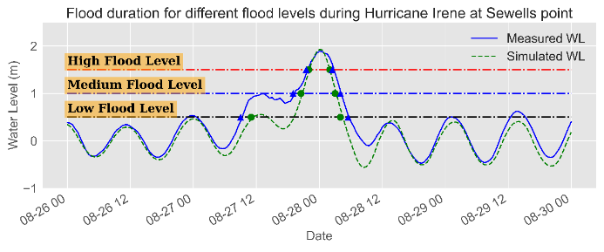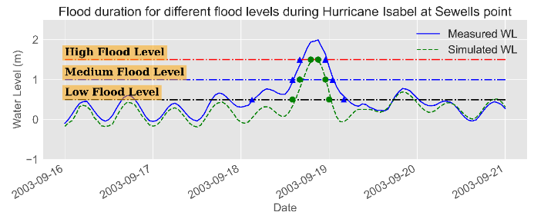

Figure 6. Flood Duration, Magnitude, and Timing at Sewells Point during Hurricane Irene-2011 (left panel) and Hurricane Isabel-2003 (right panel) at NSN, the US.

The projected flood areas, average flood depth (AFD), and maximum flood depth (MFD) were calculated on an hourly basis for about 25 hours around the peak surge that occurred on August 28th at 00:00 for Hurricane Irene and on September 18th at 18:00 for Hurricane Isabel, Figure 7. In addition, the severity of the flood was evaluated, as a function of the flood depth, where the flood areas were classified into four levels; low (0.1m – 0.25m), medium (0.25m – 0.5m), high (0.5m – 1.0m) and extreme (>1.0m) and a flood map was obtained for the peak flood (during the peak surge) using a shapefile that delineates the base area, Figure 8.

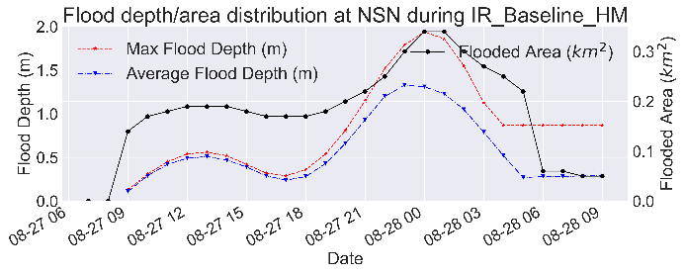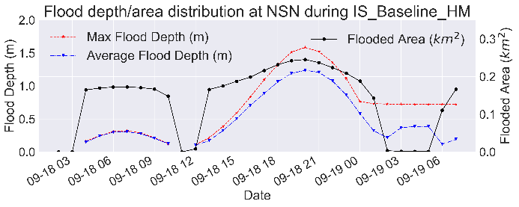

Figure 7. Time series of the projected average and maximum flood depth (left axis) and flood area (km2-right axis) during Hurricane Irene-2011 (left panel) and Hurricane Isabel-2003 (right panel) at NSN, the US.

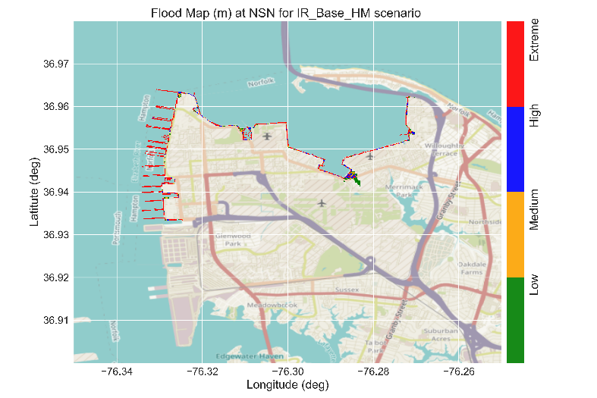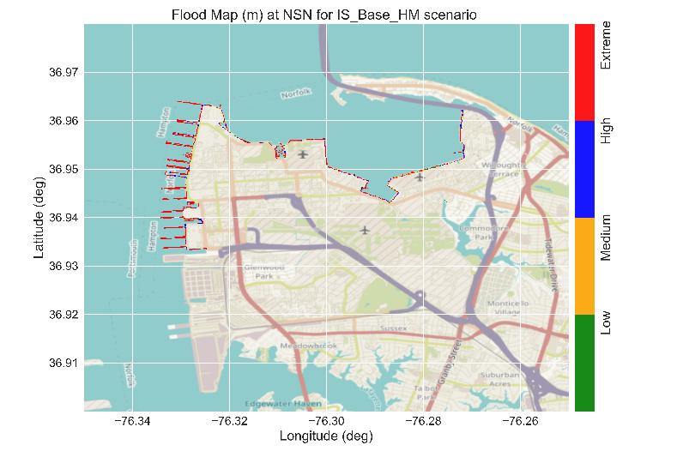

**Peak Surge: 1.55m**

**Peak Surge: 1.92m**

Figure 8. Flood map showing the classification of the flood levels at the peak surge during Hurricane Irene (left panel) and Hurricane Isabel (right panel) at NSN, the US.

Both Hurricanes had a marginal impact on the NSN base in terms of flooding where the maximum detected flood area was ~0.34 km2 and 0.24 km2 (<2% of the base area) for Irene and Isabel respectively. However, most of this flooded area is located at the coastal boundaries of the base where the actual performance of the model prediction is highly affected by different factors including the sudden changes in the bed level, the accuracy of the bathymetry (distinguishing wet and dry cells), and the model resolution that should be high enough to capture the small changes in the water depth and hence flood areas. Therefore, it would be more accurate to state that the impact of Hurricanes Irene and Isabel on the NSN base was minor (~1% of the base area) or less. In addition, the affected area is located at the northeastern part of the base, Figure 9, where it is protected by a hard structure (**probably a Seawall**) that can significantly reduce the predicted flood area. Although including this structure might reduce any overestimation in the flood prediction, (Tang & Gallien, 2023), it was not included in the model simulations due to the lack of information about its type and characteristics.

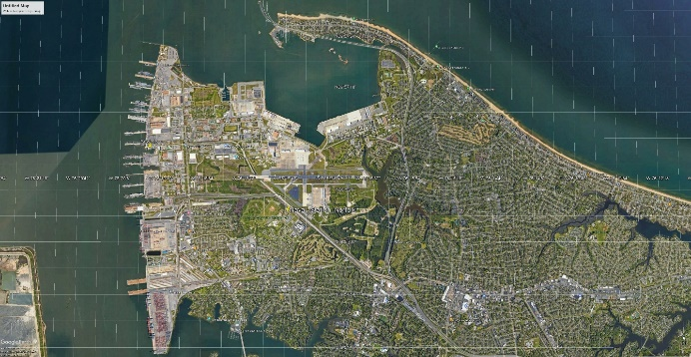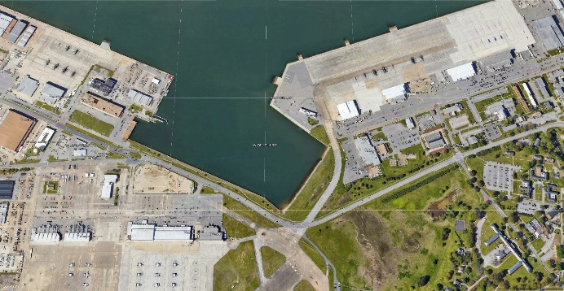

**Seawall**

Figure 9.Satellite image showing the NSN base (left panel) and a zoom-in on the projected flooded area (right panel) under the Baseline scenario at the NSN, the US.

The classification of the flood areas into flood levels does not reflect valuable information under this scenario since no significant flood was detected. However, for the consistency of the analysis through all scenarios, flood statistics were calculated for the different flood levels, **Table 3**.

The final step of the calibration was to cross-reference model results to the anecdotal data obtained from the System to Track, Organize, Record, and Map (STORM) database, <https://data.norfolk.gov/Public-Safety/STORM-System-to-Track-Organize-Record-and-Map/mrv3-rcpc/about_data>. STORM system captures data collected by residents and city staff during and after inclement weather events. Figure 10 shows the simulated flood areas for the entire Norfolk area (the base and the Willoughby Spit) and the locations where flood events were reported during Hurricane Irene 2011. It can be noticed that almost no locations were reported to be flooded, within the NSN base, during the storm except for a single location southwest of the base, which might be associated with pluvial flooding (from the heavy rain associated with the storm), which was not considered in this study. Most of the reported flooding is located at Willoughby Spit which coincides with the model flood results. Although this data is only qualitative (anecdotal), it supports the model results and increases our confidence in the model performance at the NSN base. There is no additional measured or anecdotal flood data recorded during Hurricane Isabel at the NSN base or even its surrounding area.

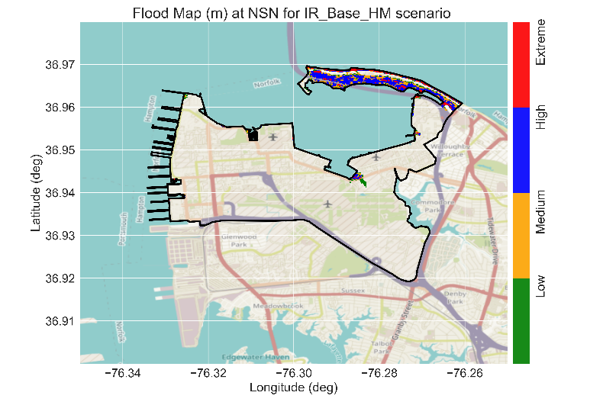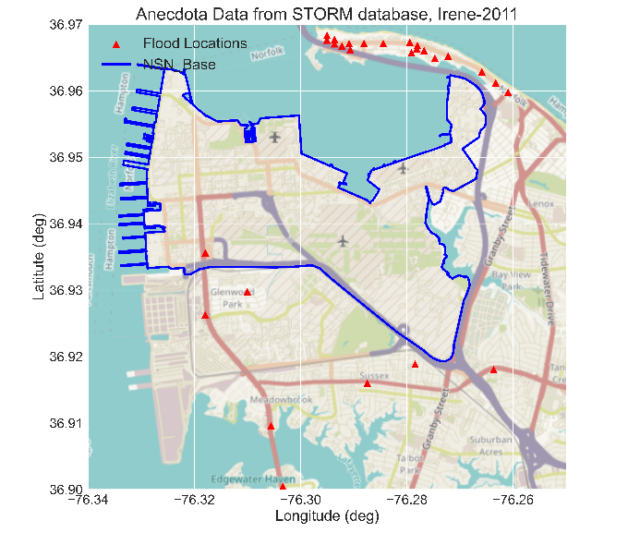

Figure 10. Flood map with flood levels (left panel) and the locations of the flood areas during Hurricane Irene based on the STORM anecdotal data (right panel). The solid blue line shows the boundary of the NSN base, and the red triangles represent the reported flood location, NSN, the US.

**Table 3. Projected flood area characteristics at the peak flood during Hurricanes Irene 2011 and Isabel 2003 for the baseline scenarios at NSN, the US**

|  |  |  |  |  |  |  |  |  |  |
| --- | --- | --- | --- | --- | --- | --- | --- | --- | --- |
| Flood level/  Hurricane | Irene | | | | | Isabel | | | |
| **AFD (m)\*** | **MFD(m)\*\*** | **FA_(km)** | **Flood %** | **AFD (m)** | | **MFD(m)** | **FA_(km)** | **Flood %** |
| Low | 0.18 | 0.25 | 0.01 | 0.11 | 0.17 | | 0.25 | 0.02 | 0.17 |
| Medium | 0.37 | 0.5 | 0.02 | 0.17 | 0.38 | | 0.5 | 0.03 | 0.2 |
| High | 0.73 | 1 | 0.04 | 0.3 | 0.74 | | 0.99 | 0.04 | 0.31 |
| Extreme | 1.53 | 1.61 | 0.2 | 1.42 | 1.71 | | 1.84 | 0.21 | 1.51 |
| No Flood | 0 | 0 | 13.5 | **97.97** | 0 | | 0 | 13.48 | 97.82 |

## Impacts of Meteorological forcing

Manipulating the hurricane’s meteorological forces is crucial for understanding and evaluating the extent of influence of these forces on the severity of the hurricane's impacts on coastal zones. This could be crucial for future predictions of hurricane impacts with similar characteristics to the hurricanes in this study.

### Pressure Drop (PD)

Three pressure drop scenarios were considered in this study. The drop of the central pressure of each hurricane by 12% (PD_F0.88), 24% (PD_F0.76), and 36% (PD_F0.64) below the recorded central pressure. The surge and flood area characteristics were obtained for all scenarios.

Reducing the central pressure of the hurricane reflected a minor increase in the peak surge magnitude at Sewells Point with an increase of 0.03m to 0.1m, Table 4. This marginal increase in the peak surge has reflected an insignificant increase in the surge duration with a maximum increase of ~0.5 hours, Figure 11.Minor changes were detected in the flood areas along the NSN base for all PD scenarios compared to the baseline scenarios for both hurricanes, Figure *11* and **Table *5***. Nevertheless, a minor increase (~0.4%) in the simulated flood area was detected for Hurricane Irene due to the proximity of the hurricane center (eye) to the NSN base. In addition, the average and maximum flood depth showed a minor response under the PD_F0.64 scenario with a maximum change of ~0.1m. Otherwise, no significant impact of the PD on the flood areas was observed for both hurricanes. The other two pressure drop scenarios, PD_F0.76 and PD_F0.88 showed lower peak surge, duration, and hence flood areas.

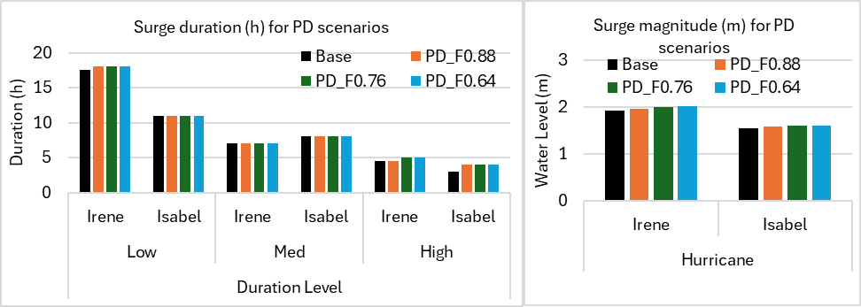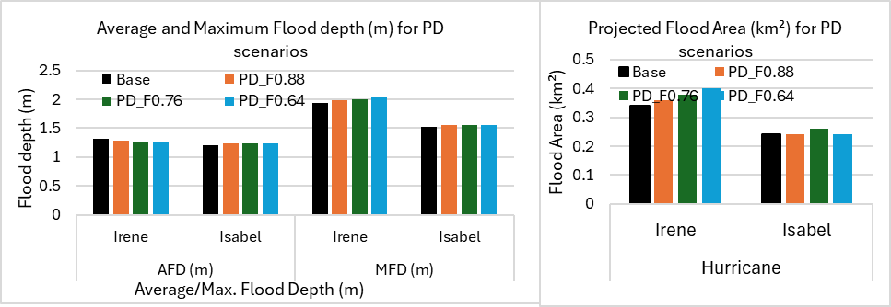

Figure 11. Peak surge (m) (left panel) and flood area (km2) (right panel) for the baseline and the PD scenarios, NSN, the US.

**Table 4. Peak surge characteristics (Maximum and Duration) of the base and PD scenarios for Hurricanes Irene and Isabel at Sewells Point, NSN, the US.**

|  |  |  |  |  |  |  |  |  |
| --- | --- | --- | --- | --- | --- | --- | --- | --- |
| Hurricane | Irene | | | | Isabel | | | |
| Metric | **Max. Surge (m)** | **Duration (h)** | | | **Max. Surge (m)** | **Duration (h)** | | |
| Scenario | Low | Med | High | Low | Med | High |
| Base | 1.92 | 17.5 | 7 | 4.5 | 1.55 | 11 | 8 | 3 |
| PD_F0.88 | 1.95 | 18 | 7 | 4.5 | 1.58 | 11 | 8 | 4 |
| PD_F0.76 | 1.99 | 18 | 7 | 5 | 1.59 | 11 | 8 | 4 |
| PD_F0.64 | 2.02 | 18 | 7 | 5 | 1.59 | 11 | 8 | 4 |

**Table 5. Flood area characteristics of the base and PD scenarios for both hurricanes at NSN, the US.**

|  |  |  |  |  |  |  |  |  |
| --- | --- | --- | --- | --- | --- | --- | --- | --- |
| Hurricane | Irene | | | | Isabel | | | |
| Scenario | AFD (m) | MFD (m) | FA (km2) | % | AFD (m) | MFD (m) | FA (km2) | % |
| Base | 1.31 | 1.94 | 0.34 | 2.47 | 1.21 | 1.52 | 0.24 | 1.72 |
| PD_F0.88 | 1.29 | 1.98 | 0.36 | 2.6 | 1.23 | 1.55 | 0.24 | 1.7 |
| PD_F0.76 | 1.26 | 2.01 | 0.38 | 2.8 | 1.23 | 1.55 | 0.26 | 1.9 |
| PD_F0.64 | 1.25 | 2.04 | 0.4 | 2.9 | 1.24 | 1.56 | 0.24 | 1.7 |

### Radius of Maximum Wind (RMW)

Three scenarios were considered for the RMW by reducing the radius by 10% and increasing it by 10% and 25%. The impact of changing the RMW was found to be minor for both hurricanes. No significant impact was observed for the peak surge for Hurricane Irene, while about a 15% increase in the peak surge was detected for Hurricane Isabel for the RMW_F1.25 scenario, Figure 12. These minor changes in the peak surge reflect marginal changes in the surge duration (1-2 hours) for Hurricane Isabel's high surge level, Table 6. Increasing the radius of the maximum extends the area dominated by the hurricane force, which can affect the water level around the peak surge. The impact on Hurricane Irene might be more visible compared to Isabel due to the proximity of Sewells Point to the hurricane center.

The same situation was observed for the flood area characteristics, Figure *13* and **Table 7**. The changes in the flood areas were marginal with a maximum flood area of less than 3.3%. Investigating the RMW_F0.9 and RMW_F1.1 shows even fewer changes over the baseline scenarios for both hurricanes.

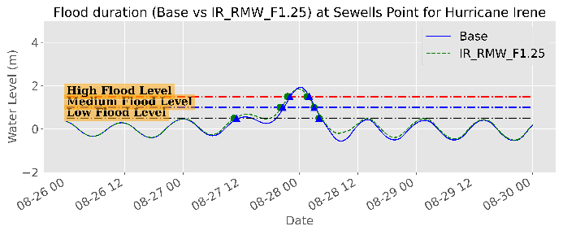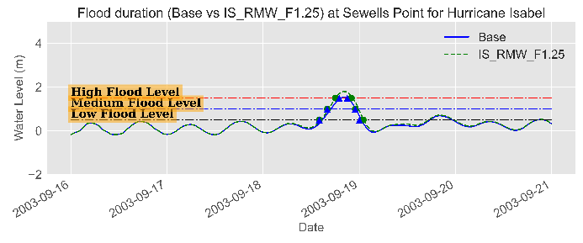

Figure 12. Example of water level time series (m) showing the surge magnitude and duration for different surge levels for the baseline and RMW_F1.25 scenarios at Sewells Point, NSN, the US.

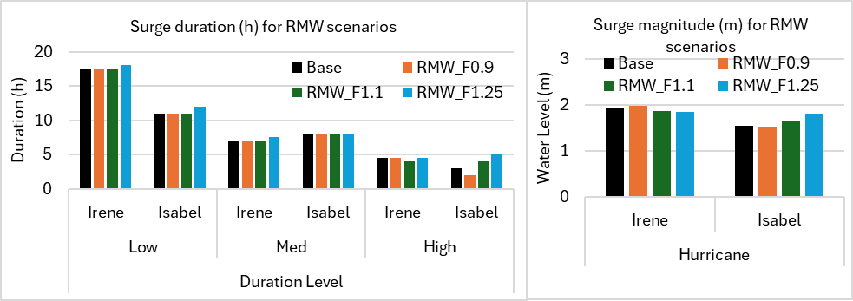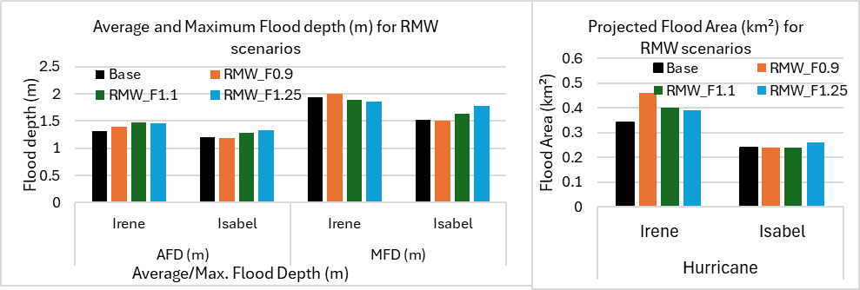

Figure 13. Peak surge (m) (left panel) and flood area (km2) (right panel) for the baseline and the RMW scenarios at NSN, the US.

**Table 6. Peak surge characteristics (Maximum and Duration) of the base and RMW scenarios for Hurricanes Irene and Isabel at Sewells Point, NSN, the US.**

|  |  |  |  |  |  |  |  |  |
| --- | --- | --- | --- | --- | --- | --- | --- | --- |
| Hurricane | Irene | | | | Isabel | | | |
| Metric | **Max. Surge (m)** | **Duration (h)** | | | **Max. Surge (m)** | **Duration (h)** | | |
| Scenario | Low | Med | High | Low | Med | High |
| Base | 1.92 | 17.5 | 7 | 4.5 | 1.55 | 11 | 8 | 3 |
| RMW_F0.9 | 1.98 | 17.5 | 7 | 4.5 | 1.52 | 11 | 8 | 2 |
| RMW_F1.1 | 1.87 | 17.5 | 7 | 4 | 1.65 | 11 | 8 | 4 |
| RMW_F1.25 | 1.84 | 18 | 7.5 | 4.5 | 1.8 | 12 | 8 | 5 |

**Table 7. Flood area characteristics of the base and RMW scenarios for all hurricanes at NSN, the US.**

|  |  |  |  |  |  |  |  |  |  |
| --- | --- | --- | --- | --- | --- | --- | --- | --- | --- |
| Hurricane | Irene | | | | Isabel | | | | |
| Scenario | AFD (m) | MFD (m) | FA (km2) | % | | AFD (m) | MFD (m) | FA (km2) | % |
| Base | 1.31 | 1.94 | 0.34 | 2.47 | | 1.21 | 1.52 | 0.24 | 1.72 |
| RMW_F0.9 | 1.4 | 2 | 0.46 | 3.3 | | 1.18 | 1.5 | 0.24 | 1.7 |
| RMW_F1.1 | 1.47 | 1.89 | 0.4 | 2.9 | | 1.28 | 1.64 | 0.24 | 1.7 |
| RMW_F1.25 | 1.46 | 1.86 | 0.39 | 2.8 | | 1.33 | 1.77 | 0.26 | 1.9 |

## Impacts of Climate Change

Two parameters were considered as climate change impacts on the hurricane’s activity and their associated impacts on the NSN base, sea level rise and Wind Speed (WS).

### Sea Level Rise

Three SLR scenarios were considered for short-term (SLR_0.4M), medium-term (SLR_0.8M), and long-term (SLR_1.3M) with 0.4m, 0.8m, and 1.3m increase in the mean sea level respectively. Increasing the mean sea level enhanced the peak surge magnitude and duration at all locations, which affected the potential flood areas. Figure 14 shows the water level for the base and the SLR_1.3M at Sewells Point. Including an SLR of 1.3m has enhanced the peak up to a maximum surge of ~3.12 m for Hurricane Irene compared to ~2.74m for Hurricane Isabel. Although the increase in the peak surge is not linear with the increase of the mean sea level, the peak surge has increased by 1.3m ±0.1 for both hurricanes. The water level increased above the medium surge level for both Hurricanes for SLR_1.3M. The high surge level duration has increased drastically by 13-20 hours compared to 3-4.5 hours for the baseline scenarios, Figure 15 and Table 9.

On the other hand, the flood area statistics, Figure 16 and Table 10, showed a significant increase in the flood area for both hurricanes under SLR_1.3M and SLR_0.8M scenarios with limited impact under the SLR_0.4M scenario. The flood area has increased from a maximum of ~0.34 km2 (<2.5%) up to ~5.4 km2 (~39%) for Hurricane Irene with a lower value for hurricanes Isabel (~20%) under SLR_1.3M. In addition, although the average flood depth showed limited changes with no detectable pattern, the maximum flood depth has significantly increased up to more than 3m.

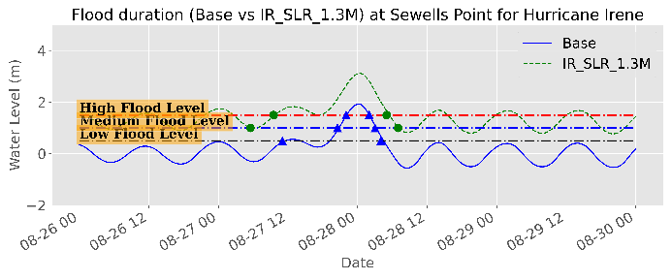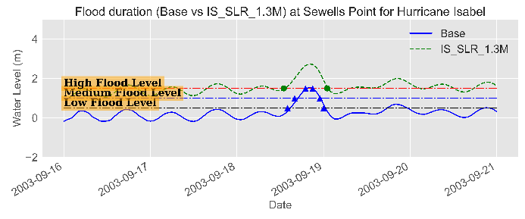

Figure 14. Example of water level time series (m) showing the surge magnitude and duration for different surge levels for the base and SLR_1.3M scenarios at Sewells Point, NSN, the US.

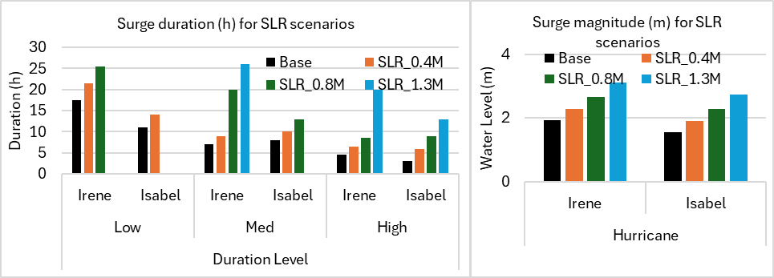

Figure 15. Peak surge (m) (left panel) and surge duration (h) of the different surge levels (right panel) for the base and the SLR scenario at NSN, the US.

**Table 8. Peak surge characteristics (Maximum and Duration) of the base and SLR scenarios for Hurricanes Irene and Isabel at Sewells Point, NSN, the US.**

|  |  |  |  |  |  |  |  |  |
| --- | --- | --- | --- | --- | --- | --- | --- | --- |
| Hurricane | Irene | | | | Isabel | | | |
| Metric | **Max. Surge (m)** | **Duration (h)** | | | **Max. Surge (m)** | **Duration (h)** | | |
| Scenario | Low | Med | High | Low | Med | High |
| Base | 1.92 | 17.5 | 7 | 4.5 | 1.55 | 11 | 8 | 3 |
| SLR_0.4M | 2.29 | 21.5 | 9 | 6.5 | 1.91 | 14 | 10 | 6 |
| SLR_0.8M | 2.66 | 25.5 | 20 | 8.5 | 2.28 | -- | 13 | 9 |
| SLR_1.3M | 3.12 | -- | 26 | 20 | 2.74 | -- | -- | 13 |

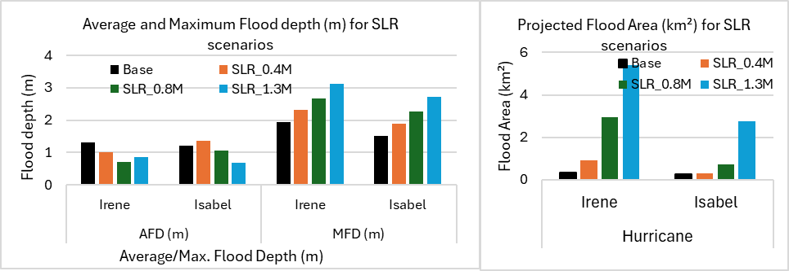

Figure 16. Average Flood Depth (AFD) & Maximum Flood Depth (MFD) in meters (left panel) and Flood area (km2) (right panel) for the base and the SLR scenarios, NSN, the US.

**Table 9. Flood area characteristics of the base and SLR scenarios at NSN, the US.**

|  |  |  |  |  |  |  |  |  |
| --- | --- | --- | --- | --- | --- | --- | --- | --- |
| Hurricane | Irene | | | | Isabel | | | |
| Scenario | AFD (m) | MFD (m) | FA (km2) | % | AFD (m) | MFD (m) | FA (km2) | % |
| Base | 1.31 | 1.94 | 0.34 | 2.47 | 1.21 | 1.52 | 0.24 | 1.72 |
| SLR_0.4M | 1.01 | 2.31 | 0.9 | 6.5 | 1.36 | 1.89 | 0.29 | 2.1 |
| SLR_0.8M | 0.71 | 2.67 | 2.94 | 21.4 | 1.06 | 2.26 | 0.72 | 5.2 |
| SLR_1.3M | 0.86 | 3.12 | 5.41 | 39.3 | 0.69 | 2.72 | 2.74 | 19.9 |

The increase in the flood magnitude and duration, especially of the high flood level, has also increased the duration of ground flooding. The flood area was stable below 0.5 km2 till the peak surge where the flood areas increased drastically along with the MFD. However, even after hours of the peak flood, the flood area and the maximum flood maintain significant values. For instance, observing Hurricane Irene, Figure 17 left panel, the flood areas remained relatively constant below 0.5 km2 till August 27th at 20:00, 4 hours before the peak surge, where the flood area increased up to 5.4 km2 and then started to decline again. However, the flood areas did not decline down to 0.5 km2, but to about 2 km2, which means that these areas will be flooded for hours (maybe days) after the peak flood occurs with an average and a maximum water depth of about 0.5 m and 2.5 m respectively.

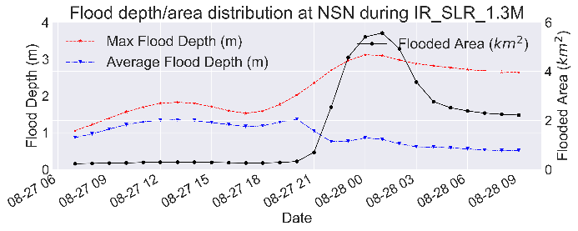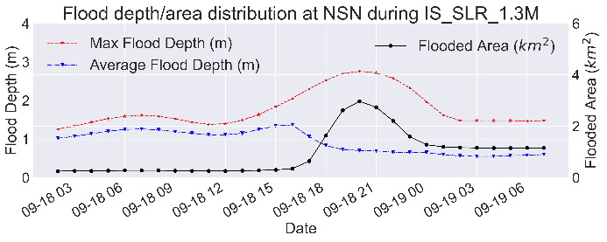

Figure 17. Time series of the projected average and maximum flood depth (left axis) and flood area (km2-right axis) for hurricanes Irene and Isabel for SLR_1.3M scenario at NSN, the US.

The spatial extent of the flood areas showed that the north and west parts of the base are the most vulnerable areas to flooding with flood levels of high to extreme (>0.5m above ground level), Figure 18. The extreme flood level (red color: >1m above ground level) concentrated at the golf course and a residential area in the northeast part of the base.

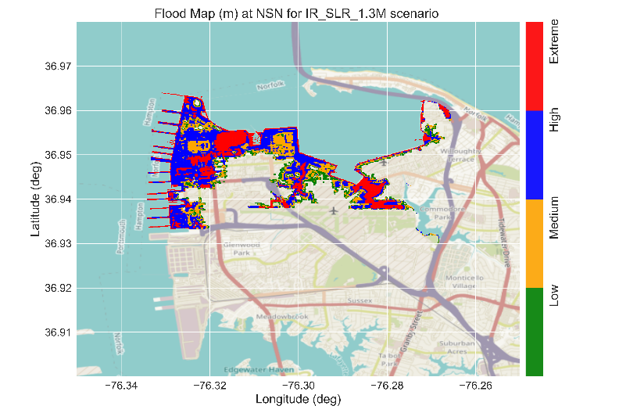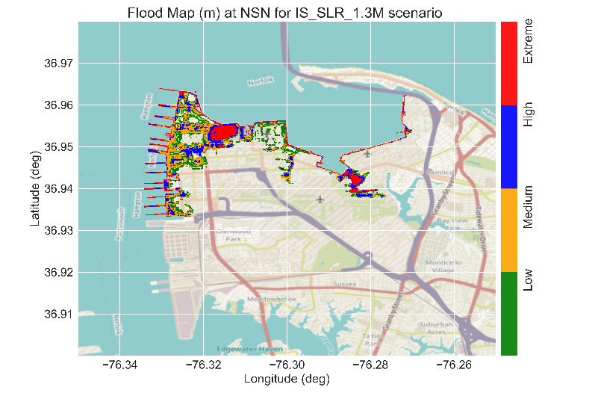

Figure 18. Example of the flood maps with the flood levels during the peak surge for the SLR_1.3M scenario at NSN, the US.

### Increasing Wind Speed

Increasing the hurricane wind speed will eventually enhance the peak surge magnitude and duration which will reflect on the potential flood areas. We considered three scenarios for wind speed change, decreasing the wind speed by 7.5% (WSF_0.925), increasing the wind speed by 7.5% (WSF_1.075), and enhancing the wind speed by 22.5% (WSF_1.225).

Enhancing the wind speed by 22.5% resulted in a significant increase in the peak surge for Hurricane Irene with minor changes for Hurricane Isabel at Sewells Point, Figure 19. A maximum surge of about 2.66m and 1.82m (an increase of 0.74m and 0.27m over the baseline) was observed for hurricanes Irene and Isabel respectively. We should note that we are only evaluating the impacts on the surge magnitude at Sewells Point due to its proximity to the NSN base. However, different results might be obtained at different stations, particularly stations closer to the hurricane’s tracks. For instance, a higher impact of enhancing the wind speed was obtained at Duck for Hurricane Isabel with an increase in surge magnitude of about 0.71m, which is in the same magnitude as the increase at Sewells Point for Hurricane Irene. Decreasing or increasing the wind speed by 7.5% showed limited impact on the surge magnitude for both hurricanes at NSN. This is also reflected in the surge duration where no observable impact was detected on low and high surge levels for Hurricane Isabel with a minor impact for Hurricane Irene that ranges from -0.5 h to +2.5 h for all scenarios, Figure 20 and Table 10.

On the other hand, the flood area statistics, Figure 23 and Table 12, showed insignificant change in the flood area for Hurricane Isabel under this scenario group. However, the average and maximum flood depth have significantly increased up to 0.16 m and 0.25 m respectively. A significant increase in the flood area however was detected under the influence of Hurricane Irene where about 3.15km2 (23%), Figure 24, of the NSN was found to be susceptible to flooding under the WSF_1.225 scenario. Most of these areas lie mostly under the high and extreme flood categories representing ~43% of the total flood area at NSN base. In addition, although the AFD has decreased to ~0.7m, the MFD has significantly increased up to 2.7m, which might have more severe consequences on the affected areas. A detectable change was also obtained for WSF_0.925 and WSF_1.075 scenarios with potential flood of 2.2% and 4.3% for both scenarios respectively.

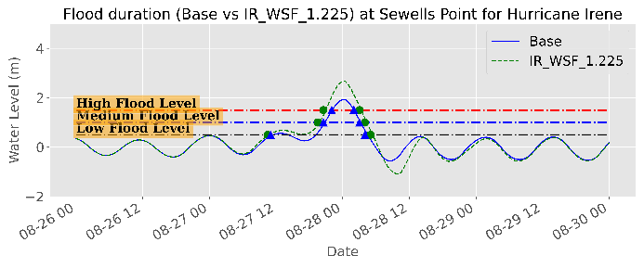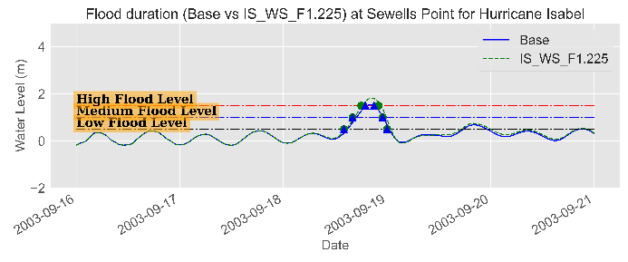

Figure 19. Example of water level time series (m) showing the surge magnitude and duration for different surge levels for the base and WSF_1.225 scenarios at Sewells Point, NSN, the US.

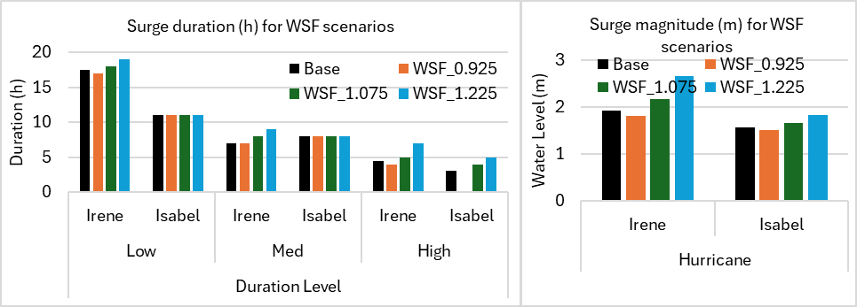

Figure 20. Peak surge (m) (left panel) and surge duration (h) of the different surge levels (right panel) for the base and the WS scenario at NSN, the US.

**Table 10. Peak surge characteristics (Maximum and Duration) of the base and WS scenarios for Hurricanes Irene and Isabel at Sewells Point, NSN, the US.**

|  |  |  |  |  |  |  |  |  |
| --- | --- | --- | --- | --- | --- | --- | --- | --- |
| Hurricane | Irene | | | | Isabel | | | |
| Metric | **Max. Surge (m)** | **Duration (h)** | | | **Max. Surge (m)** | **Duration (h)** | | |
| Scenario | Low | Med | High | Low | Med | High |
| Base | 1.92 | 17.5 | 7 | 4.5 | 1.55 | 11 | 8 | 3 |
| WSF_0.925 | 1.81 | 17 | 7 | 4 | 1.5 | 11 | 8 | -- |
| WSF_1.075 | 2.17 | 18 | 8 | 5 | 1.66 | 11 | 8 | 4 |
| WSF_1.225 | 2.66 | 19 | 9 | 7 | 1.82 | 11 | 8 | 5 |

The ground flood duration maintained a significant value of ~1 km2 (~7.25%) after hours of the peak surge time during Hurricane Irene with AFD and MFD of ~0.5 m and ~2.2 m. However, the limited increase in the flood magnitude and duration did not have an influence on the duration of ground flooding for Hurricane Isabel.

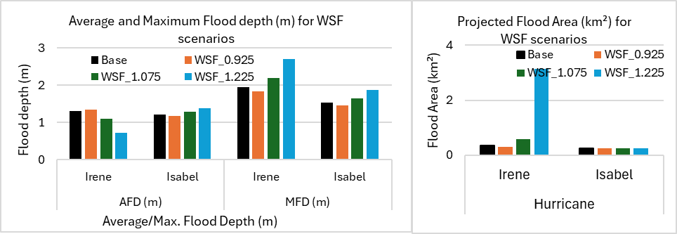

Figure 21. Average Flood Depth (AFD) & Maximum Flood Depth (MFD) in meters (left panel) and Flood area (km2) (right panel) for the base and the WS scenarios, NSN, the US.

**Table 11. Flood area characteristics of the base and WS scenarios at NSN, the US.**

|  |  |  |  |  |  |  |  |  |
| --- | --- | --- | --- | --- | --- | --- | --- | --- |
| Hurricane | Irene | | | | Isabel | | | |
| Scenario | AFD (m) | MFD (m) | FA (km2) | % | AFD (m) | MFD (m) | FA (km2) | % |
| Base | 1.31 | 1.94 | 0.34 | 2.47 | 1.21 | 1.52 | 0.24 | 1.72 |
| WSF_0.925 | 1.34 | 1.83 | 0.3 | 2.2 | 1.17 | 1.46 | 0.24 | 1.7 |
| WSF_1.075 | 1.09 | 2.19 | 0.59 | 4.3 | 1.28 | 1.65 | 0.25 | 1.8 |
| WSF_1.225 | 0.71 | 2.69 | 3.15 | 22.9 | 1.37 | 1.87 | 0.26 | 1.9 |

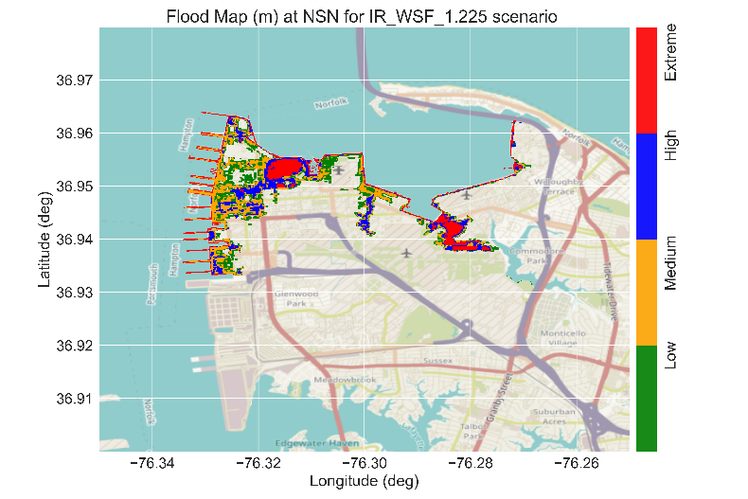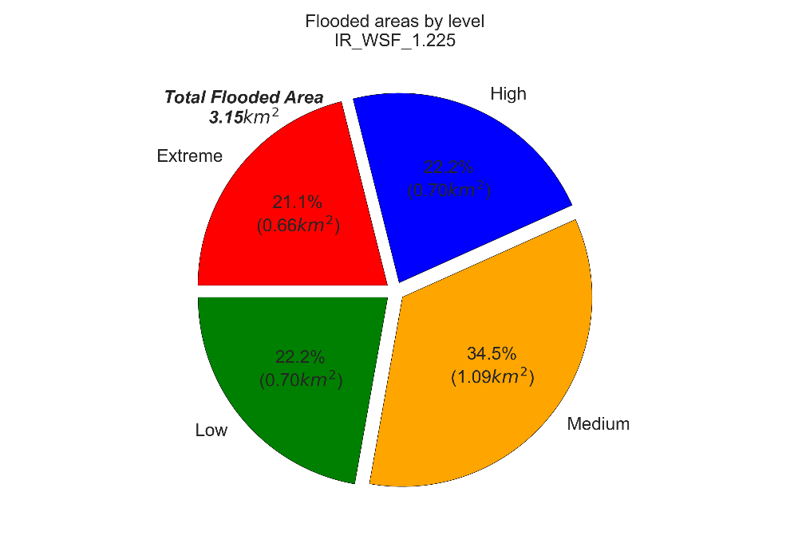

Figure 22. Example of the flood map with the flood levels during the peak surge (left panel) and the corresponding areas and percentages (right panel) for the WSF_1.225 scenario for Hurricane Irene at NSN, the US.

### Impacts of Lack of Data (Degradation scenarios)

The lack of accurate representative data has always been a challenge for coastal modelers. One of the most important parameters of hurricanes is the hurricane track. Inaccuracy in the track prediction can lead to underestimation of the hurricane’s impact at one place with overestimation at the other. This can lead to catastrophic loss of human lives on one hand and cause significant loss in unnecessary evacuation on the other hand.

Bathymetric and topographic data are available from numerous sources and with different resolutions and accuracies. The absence of accurate topographic data can cause overestimation/underestimation of the predicted flood area and hence, affect the reliability of coastal flood predictions. On the other hand, the model resolution (mesh resolution) can have a significant impact on the model performance. Generally speaking, the model performance is proportional to the mesh resolution, especially for flood prediction simulations. However, the computational cost also increases with increasing the model resolution. Therefore, a balance must be achieved between these aspects to implement feasible simulations.

The performance of the model in predicting the water level and the flood areas under controlled perturbations in the hurricane track, bathymetric accuracy, and bathymetry/mesh resolution were evaluated. Six scenarios were considered for changing the hurricane track by shifting the original track to the east and the west by 54nm, 96nm, and 138nm. Three scenarios were considered for bathymetric accuracy by adding a Gaussian noise of 0.3m, 0.5m, and 1.0m to the original bathymetry/topography data. Four scenarios were considered for changing the mesh resolution through decreasing the resolution by factors of 5, 16, 33, and 66. These factors correspond to a maximum resolution of about 75m, 250m, 500m, and 1000m.

#### Strom Track Shift (Error in Storm Track Prediction)

Changing the storm track showed a significant impact on the peak surge characteristics, Figure 23. Specifically speaking, shifting Irene’s track to the west (left panels of *Figure 23*) has resulted in a drastic decrease in the peak surge. The peak surge diminishes below the low surge level after shifting the track by 96nm. The track of Hurricane Irene can be considered a coast-parallel track, Figure *26*, hence shifting the track to the west resulted in the displacement of a significant part of the hurricane on land resulting in a lower influence on the ocean surface. In addition, a negative surge down to -2 m was observed when shifting the track by 96nm and 138nm to the west where the offshore wind became the more dominant water level driving force. Shifting the track to the east (right panels of *Figure 23*) has also resulted in a declining water level. Although the east shift will move the hurricane further to the ocean, the influence of the hurricane becomes weaker at Sewells Point as the point is now located further away from the hurricane's eye at weaker winds. Nevertheless, the east shift scenarios have higher surge values when compared to the west shift scenarios. A similar pattern was observed for the surge duration for all levels, *Figure 24* and ***Table 12***. No high surge level was detected for all scenarios (zero duration). The medium surge level was detected only for the 54nm scenarios for both directions but with a ~30% decrease in the surge duration.



Figure 23. Water level time series (m) during Hurricane Irene showing the surge magnitude and duration for different surge levels for the base and Storm Track Shift scenarios at Sewells Point, NSN, the US.



Figure 24. Peak surge (m) (left panel) and surge duration (h) of the different surge levels (right panel) for the baseline and the storm track shift scenarios for Hurricane Irene at NSN, the US. West shifts and east shifts are in green and red gradients respectively.

**Table 12. Peak surge characteristics (Maximum and Duration) of the base and storm track shift scenarios for Hurricane Irene at Sewells Point, NSN, the US.**

|  |  |  |  |  |  |
| --- | --- | --- | --- | --- | --- |
| Group | Scenario | Peak Surge (m) | Duration (h) | | |
| **Low** | **Med** | **High** |
| Storm Track Shift (nm) | **IR_STW_138** | 0.34 | 0 | 0 | 0 |
| **IR_STW_96** | 0.44 | 0 | 0 | 0 |
| **IR_STW_54** | 1.4 | 18 | 5 | 0 |
| **Baseline** | 1.92 | 17.5 | 7 | 4.5 |
| **IR_STE_54** | 1.22 | 18.5 | 4.5 | 0 |
| **IR_STE_96** | 0.87 | 6 | 0 | 0 |
| **IR_STE_138** | 0.71 | 5 | 0 | 0 |

On the other hand, the flood area statistics, *Figure 25* and **Table *13***, showed a decrease in the flood area for all simulations compared to the baseline simulation under this scenario group. The flood area has decreased from ~0.34 km2 down to ~0.24 km2 (~1.7%) and 0.28 km2 (2%) for the west and east track shifts respectively. In addition, the AFD and MFD have also diminished down to 0.32 m and 0.39 m respectively for the west shift simulations and 0.65 m and 0.69 m respectively for the east shift simulations. The reduction in the flood magnitude and duration, especially of the high and medium flood levels, has also reduced the duration of ground flooding. The spatial extent of the flood areas showed no significant flooding, which means that the original Irene track was the worst-case scenario.



Figure 25. Average Flood Depth (AFD) & Maximum Flood Depth (MFD) in meters (left panel) and Flood area (km2) (right panel) of Hurricane Irene for the Base and storm track shift scenarios at NSN, the US. West shifts and east shifts are in green and red gradients respectively.

**Table 13. Flood area characteristics of the base and storm track shift scenarios for Hurricane Irene at NSN, the US.**

|  |  |  |  |  |  |
| --- | --- | --- | --- | --- | --- |
| Group | Scenario | Flood Depth (m) | | FA (km2) | FA (%) |
| **AFD** | **MFD** |
| Storm Track Shift (nm) | **IR_STW_138** | 0.32 | 0.39 | 0.26 | 1.89 |
| **IR_STW_96** | 0.42 | 0.52 | 0.24 | 1.74 |
| **IR_STW_54** | 1.09 | 1.26 | 0.31 | 2.25 |
| **Baseline** | 1.31 | 1.94 | 0.34 | 2.47 |
| **IR_STE_54** | 1.1 | 1.24 | 0.32 | 2.32 |
| **IR_STE_96** | 0.8 | 0.86 | 0.29 | 2.11 |
| **IR_STE_138** | 0.65 | 0.69 | 0.28 | 2.03 |

Hurricane Isabel has a different track compared to Hurricane Irene. Isabel approaches the US East coast at an angle of ~325 degrees with North where it makes landfall near Drum Inlet on the Outer Banks of North Carolina, Figure 26. Shifting the track of Isabel to the eastward or westward directions won’t have a meaningful impact on the original track. Therefore, we shifted Hurricane Isabel's track by 54nm, 96nm, and 138nm but with 45 degrees.

Shifting Isabel's track to the west has resulted in a drastic decrease in the peak surge at Sewells Point. Shifting the track to the west will displace the hurricane further away from NSN resulting in a lower surge characteristic. On the other hand, shifting Isabel’s track to the east resulted in a higher surge characteristic, Figure 27 and **Table 14**.

A significant decrease down to 0.58 m and an increase up to 3.2 m in the surge magnitude is associated with the west shift and east shift respectively, (compared to 1.55m for the baseline). This pattern is also reflected in the surge duration where a significant increase was detected for IS_STE_54nm and IS_STE_96nm scenarios up to 5 hours. Shifting the track further to the east (IS_STE_138nm) yielded very close results to the baseline scenario since the hurricane shifted more than 70 nm east to the NSN base.

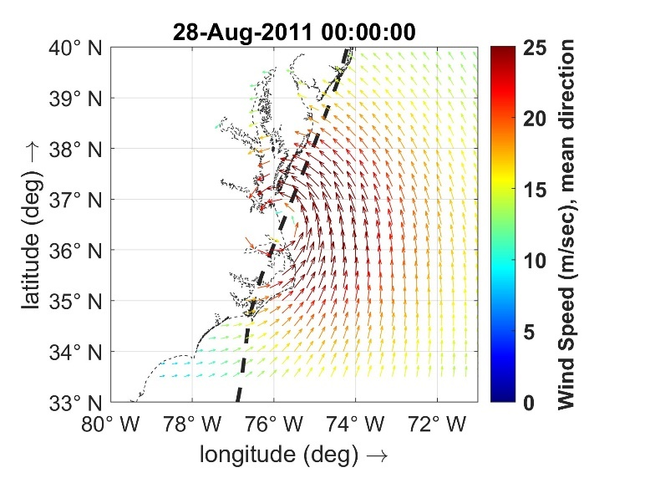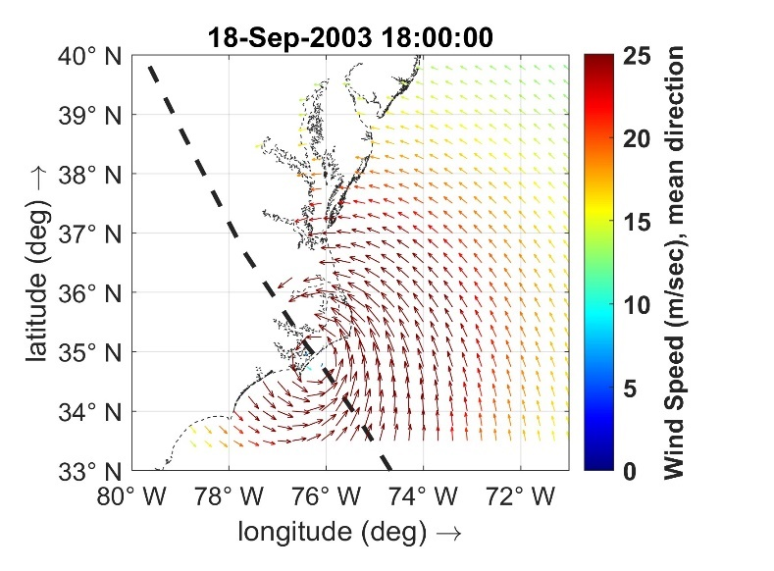

Figure 26. Wind speed (m/sec), from ECMWF-ERA5 winds, during Hurricanes Irene 2011 (left panel) and Isabel 2003 (right panel). The black line shows the hurricane track.



Figure 27. Peak surge (m) (left panel) and surge duration (h) of the different surge levels (right panel) for the base and the storm track shift scenarios for Hurricane Isabel at NSN, the US. West shifts and east shifts are in green and red gradients respectively.

**Table 14. Peak surge characteristics (Maximum and Duration) of the base and storm track shift scenarios for Hurricane Isabel at Sewells Point, NSN, the US.**

|  |  |  |  |  |  |
| --- | --- | --- | --- | --- | --- |
| Group | Scenario | Peak Surge (m) | Flood Level/Duration (h) | | |
| **Low** | **Med** | **High** |
| Storm Track Shift (nm) | **IS_STW_138** | 0.58 | 4 | -- | -- |
| **IS_STW_96** | 0.63 | 5 | -- | -- |
| **IS_STW_54** | 0.82 | 7 | -- | -- |
| **Baseline** | 1.55 | 11 | 8 | 3 |
| **IS_STE_54** | 3.2 | 12 | 10 | 8 |
| **IS_STE_96** | 2.92 | 12 | 9 | 7 |
| **IS_STE_138** | 1.66 | 9 | 6 | 3 |

The flood area statistics, Figure *28* and ***Table 15***, showed a decrease in the flood area with the west shifts and a drastic increase for east shift simulations. An increase up to ~6 km2 and 5.2 km2 was detected for the IS_STE_54nm and IS_STE_96nm scenarios respectively. In addition, the AFM and MFD have also diminished down to 0.5 m for the west shift and increased up to 0.85 m and 3.25 m respectively for the east shift simulations. This pattern was reflected on the duration of the ground flooding where large areas (up to 2 km2) maintain flooding for hours (or days) with an average and maximum flood depth of about 0.5m and 2.5 m respectively, with the east shift simulations. The west shift of Hurricane Isabel’s track has almost no influence on the flood areas and the duration of the ground flooding.



Figure 28. Average Flood Depth (AFD) & Maximum Flood Depth (MFD) in meters (left panel) and Flood area (km2) (right panel) of Hurricane Isabel for the Base and storm track shift scenarios at NSN, the US. West shifts and east shifts are in green and red gradients respectively.

**Table 15. Flood area characteristics of the base and storm track shift scenarios for Hurricane Isabel at NSN, the US.**

|  |  |  |  |  |  |
| --- | --- | --- | --- | --- | --- |
| Group | Scenario | Flood Depth (m) | | FA (km2) | FA (%) |
| **AFD** | **MFD** |
| Storm Track Shift (nm) | **IS_STW_138** | 0.44 | 0.47 | 0.18 | 1.31 |
| **IS_STW_96** | 0.49 | 0.54 | 0.19 | 1.38 |
| **IS_STW_54** | 0.64 | 0.75 | 0.2 | 1.45 |
| **Baseline** | 1.21 | 1.52 | 0.24 | 1.74 |
| **IS_STE_54** | 0.84 | 3.25 | 5.94 | 43.14 |
| **IS_STE_96** | 0.77 | 3.02 | 5.21 | 37.84 |
| **IS_STE_138** | 1.19 | 1.61 | 0.28 | 2.03 |

#### Bathymetry Accuracy

Three scenarios were considered for the bathymetry accuracy for Hurricane Irene only by adding a Gaussian noise of 0.3m (IR_Bathy_Acc_GN_0.3m), 0.5m (IR_Bathy_Acc_GN_0.5m), and 1.0m (IR_Bathy_Acc_GN_1.0m). The minor inaccuracies in the bathymetric data were found to have no impact on the prediction of the water level and the peak surge characteristics.

Although no changes were observed in the peak surge magnitude and duration, an increase in the predicted flood areas was observed with a significant increase for the Bathy_Acc_GN_1.0m scenario, Table 16. The predicted flood area increased from 0.34 km2 (~2.47%) for the baseline scenario to about 0.48 km2 (~3.5%) for the Bathy_Acc_GN_1.0m scenario. No detectable change was reported for the AFD and MFD.

**Table 16. Flood area characteristics of the base and bathymetry accuracy scenarios at NSN, the US.**

|  |  |  |  |  |  |
| --- | --- | --- | --- | --- | --- |
| Group | Scenario | AFD (m) | MFD (m) | Flood area (km2) | Flood (%) |
| Deg. Sc. | **Base** | 1.31 | 1.94 | 0.34 | 2.47 |
| **Bathy_Acc_GN_0.3m** | 1.27 | 1.94 | 0.36 | **2.6** |
| **Bathy_Acc_GN_0.5m** | 1.23 | 1.94 | 0.38 | **2.8** |
| **Bathy_Acc_GN_1m** | 1.1 | 1.93 | 0.48 | **3.5** |

#### Bathymetry Resolution

Four scenarios were considered for the bathymetry/mesh resolution for Hurricane Irene only by decreasing the resolution of the baseline simulation by a factor of 5 (IR_Bathy_Res_F05), 16 (IR_Bathy_Res_F16), 33 (IR_Bathy_Res_F33), and 66 (IR_Bathy_Res_F66). Although the model resolution has been reduced drastically from 15m down to 1000m, the model performance in terms of water level and peak surge prediction was still relatively accurate. A maximum change in the peak surge was about -0.05m for the Bathy_Res_F66 scenario, which is still acceptable even with this low-resolution mesh.

Although no changes were observed in the peak surge magnitude and duration, the influence of resolution degradation on flood area prediction was enormous. The lower resolution reflected an inaccurate topographic representation of the base in terms of elevation and spatial representations. This resulted in an unrealistic increase in the predicted flood areas for all scenarios, Table 17. The predicted flood area has increased from 0.34 km2 (~2.47%) for the baseline up to ~7 km2 (~51%) for the Bathy_Res_F66 scenario. The spatial extent of the flood areas became dominated by the *pixilated nature* of the mesh rather than the actual topography**.** In addition, the AFD has increased from 1.3 m for the baseline scenario up to 1.85 m. No change was reported for the MFD for all scenarios.

**Table 17. Flood area characteristics of the base and bathymetry Resolution scenarios at NSN, the US.**

|  |  |  |  |  |  |
| --- | --- | --- | --- | --- | --- |
| Group | Scenario | AFD (m) | MFD (m) | Flood area (km2) | Flood (%) |
| Deg. Sc. | **Base** | 1.31 | 1.94 | 0.34 | 2.47 |
| **Bathy_Res_F05** | 1.23 | 1.96 | 1.18 | 8.6 |
| **Bathy_Res_F16** | 1.67 | 1.96 | 2.43 | 17.6 |
| **Bathy_Res_F33** | 1.85 | 1.94 | 3.77 | 27.4 |
| **Bathy_Res_F66** | 1.83 | 1.89 | 6.99 | 50.8 |

# Discussion

The model performance in predicting the magnitude and timing of the peak surge was relatively accurate with an average RMSE and bias of ~0.22 m (less than 7% of the water level range) and -0.14 m. In addition, the model was able to capture the timing of the peak surge with ±1 h accuracy. These results are comparable to the results of (Bakhtyar et al., 2020b). They were able to predict the TWL with an RMSE and Bias of about 0.15 m - 0.30m and -0.02m – 0.12 m during Hurricane Isabel; and 0.17 – 0.24 m and -0.14 m– 0.09 m for Hurricane Irene respectively. However, they focused on Delaware Bay, and they also included the fluvial effect by coupling D-Flow FM with a hydrologic model (National Water Model). The model prediction skill is highly affected by the wind input and the proximity of the area of interest to the track of the hurricane. Without any background wind, the Holland Model seems to underestimate the wind field with increasing the distance from the hurricane eye, which resulted in a significant underestimation in the predicted water levels. To overcome this problem the model could be forced with a background wind to compensate for the underestimation of the Holland model. However, for areas relatively close to the hurricane track, close to the Rmax, using the Holland model is sufficient for the water level prediction associated with hurricane activity. Some underestimation in the duration of the different surge levels was expected due to the underestimations in the surge magnitude. However, the model generally captures the medium and high surge levels duration with acceptable accuracy (3 hours within the peak surge) with some exceptions during Hurricane Isabel.

Figure 29 and Figure 30 show the summary characteristics of the peak surge, duration, and flood areas along the NSN base during hurricanes Irene and Isabel respectively. The peak surge and flood area characteristics were found to be very sensitive to the climate change-related scenarios (SLR and WS scenarios). The SLR raises the water level to an extent that might cause more frequent flooding with even high tides, and it might cause a permanent inundation of the coastal lowland such as the Willoughby Spit. On the other hand, the contribution of the wind speed in storm surge is much higher than the contribution of the atmospheric pressure change. Therefore, the sensitivity of the model results to the changes in the wind speed are relatively high.

All surge level durations increased for these scenarios with the maximum high-level surge duration of about 20 h and a maximum magnitude of ~3.12 m and 2.74 m for Irene and Isabel respectively. These results were associated with an increasing pattern in the flood area characteristics where two distinguishable peaks can be observed for the flood area of 5.41km2, and ~3.15km2 for SLR_1.3M, and WSF_1.225 scenarios respectively for Hurricane Irene, while one distinguishable peak was observed for the flood area of ~2.75km2 for the SLR_1.3M scenario for Hurricane Isabel. In addition, the maximum flood depth was found to continuously increase for these scenarios up to more than 3 m. Furthermore, the increase in the flood magnitude and duration, especially of the high flood level, has reflected an increase in the duration of ground flooding. Even after hours of the peak flood, the flood area and the maximum flood maintain significant values, e.g. 2 km2 for IR_SLR_1.3M, which means that these areas will be flooded for hours (maybe days) after the peak flood occurs with an average and a maximum water depth of about 0.5m and 2.5m respectively.

The response of Hurricane Isabel to the considered perturbations, at Sewells Point, was different compared to Hurricane Irene. That is mainly because of the difference in the tracks, of course among other factors such as the hurricane category. In addition to SLR, the peak surge and flood area characteristics were found to be sensitive to the ST East shifts perturbation and less sensitive to the other perturbations, including WS, Figure 30.

Figure 29. Peak surge characteristics (upper panel), Duration (h)-left axis and Magnitude (m)-right axis; and Flood area statistics (lower panel), average and maximum flood depth (m)-left axis and flood area (km2)-right axis for all scenarios for Hurricane Irene 2011 at NSN base, the US.

Figure . Peak surge characteristics (upper panel), Duration (h)-left axis and Magnitude (m)-right axis; and Flood area statistics (lower panel), average and maximum flood depth (m)-left axis and flood area (km2)-right axis for all scenarios for Hurricane Isabel 2003 at NSN base, the US.

Unlike Hurricane Irene, enhancing the wind speed has increased the peak surge magnitude (1.82 m, 17% above the baseline) and the high surge duration (up to 5 h, compared to 3 h for the baseline), however, no significant influence was detected on the flood areas, with only a minor increase in the MFD. Hurricane Isabel’s eye was more than 119 nm away from the NSN base with a radius of maximum wind (Rmax) of ~45 nm (during the peak surge) resulting in a maximum wind speed of 30% - 35% lower than the maximum wind of the hurricane at NSN. Therefore, enhancing the wind speed by up to 22.5% resulted in a maximum wind at the NSN base lower than the maximum wind of the hurricane by about 15%-20%. This might be the reason for the limited impact of the WS scenarios on the surge and flood area characteristics for Hurricane Isabel. Therefore, a higher impact of enhancing the wind speed is obtained at Duck (closer to the track) with an increase in surge magnitude of about 0.71m (2.8 m), Figure 31.

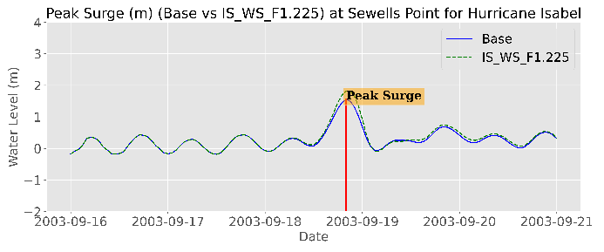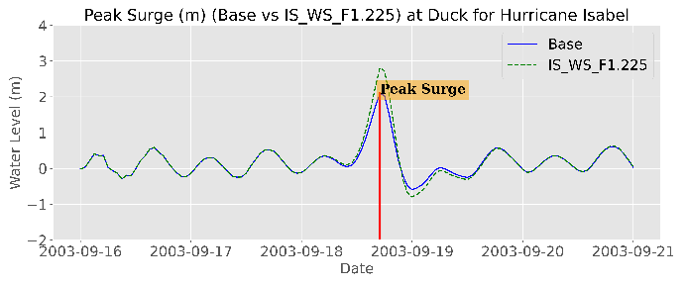

Figure 31. Water level (m) showing the surge magnitude for the base and WSF_1.225 scenarios at Sewells Point (left panel) and Duck (right panel) during Hurricane Isabel 2003.

Changing the central pressure of the hurricane (PD scenarios) and the radius of the maximum wind (RMW scenarios) did not have a significant impact on the peak surge characteristics. In addition, no noticeable influence was detected in the flood areas for these scenarios as well.

The model results were found to be very sensitive to any changes in the hurricane track. Changes in the hurricane track could result in displacement of the area of interest closer to the region of Rmax resulting in higher influence on the water level, or far from Rmax, resulting in lower water level, depending on the wind direction. Hurricane Irene passed very close to the NSN base and, therefore with its original track, had the worst impact on the base, and shifting the hurricane track to the east or the west resulted in a diminished impact of the hurricane at the NSN base, with probable higher impact elsewhere, Figure 29. However, shifting Isabel’s track to the east resulted in the displacement of the hurricane much closer to the NSN base causing a significant increase in the peak surge up to 3.2 m and flood area up to ~6 km2. Shifting the track beyond 96nm resulted in weaker winds with a strong offshore wind direction causing a lower peak surge with very low flood area characteristics that were comparable to the baseline values, Figure 30.

Degrading the bathymetry/topography accuracy and resolution did not have a significant influence on the prediction performance of the model in terms of peak surge characteristics. In addition, minor inaccuracies in the bathymetry/topography did not reflect a significant change in the predicted flood area. However, an unrealistic increase (more than 50% of the base area) in the predicted flood area might occur with a very low mesh resolution (1km). Even with a factor of 5 of resolution reduction (minimum resolution of 75 m), the predicted flood area was significantly and unrealistically higher (>8.5%) compared to the baseline scenario. Applying more resolution reduction resulted in a model mesh that no longer represents the base topography in terms of elevation and extent. This resulted in a flood prediction that was driven by the pixelated nature of the mesh rather than the actual topography. However, the lower resolution has led to a drastically lower computational time of model simulations. The simulation time was reduced from about 14 h for the base simulation (~15 m resolution) down to 0.35h for the Bath_Res_F66 scenario (~1km resolution). The decision of the appropriate resolution of the model should be judged based on the main purpose of the model. For instance, if the main aim is to predict the water level and observe the peak surge, lower-resolution fast simulations can be carried out. However, if the main purpose is to predict coastal flooding associated with different extreme events, higher resolution, yet computationally expensive, simulations might be essential. Numerous test trials could be implemented to achieve the middle ground between both approaches especially if the main aim is to develop an operational prediction model, that considers several physical and meteorological parameters, that can efficiently predict potential coastal flooding promptly to inform decision-makers.

# Conclusions

D-Flow FM model was used to evaluate the sensitivity of water level and coastal flood prediction to the combined impact of extreme weather events, such as hurricanes, and climate change. The model was forces by a parametric wind data (Holland Model - HM). Two historical hurricanes were simulated, Irene and Isabel in 2011 and 2003 respectively. The model was used to predict the peak surge characteristics (magnitude, timing, and duration) and flood area characteristics (spatial extent, average and maximum flood depth). The sensitivity of the water level (storm surge) and flood prediction to climate change impacts (SLR and WS), meteorological impacts (PD and RMW), and the potential inaccuracies in the model outputs (storm track error, bathymetry accuracy, and mesh resolution) were investigated. The calibrated model was applied to the Naval Station Norfolk (NSN) base on the United States east coast.

The model results show good agreement with the water level measurements with an average RMSE of ~0.23 m (~10%). The model skill in water level prediction is highly dependent upon the proximity of the hurricane track to the area of interest. D-Flow FM was able to detect the timing of the peak surge characteristics with high accuracy.

The two hurricanes showed variable responses to the different perturbations, which might depend upon the hurricane characteristics including track, category, and where the analysis is carried out relative to the hurricane’s track. Both hurricanes showed high sensitivity to climate change impacts, especially the SLR, followed by the changes in the hurricane track, which can significantly impact the model results in the vicinity of the modified track. Increasing the sea level (SLR) might not only increase the vulnerability of the NSN base to more frequent flooding but also might cause more severe permanent flooding (inundation) rather than temporary extreme event-related flooding. Increasing the wind speed significantly affects both hurricanes with a more pronounced impact at closer locations to the hurricane tracks, e.g., Duck for Hurricane Isabel. On the other hand, modifying the pressure drop (PD) or the radius of maximum wind (RMW) showed marginal impacts on the model outputs. The impact of the central pressure drop is manifest at and around the center of the storm with lower impact with increased distance from the eye.

Shifting the hurricane track showed a significant impact on the predicted water level and the associated flooding. However, the quantifiable impact can be detected in the vicinity of the center of the hurricane. For instance, shifting Hurricane Isabel to the east resulted in a substantial increase in the peak surge and associated flooding at NSN. However, more severe impacts were detected at closer locations to the modified tracks. The potential error in a hurricane track can lead to misleading overprediction and underprediction at the wrong locations, which can result in inaccurate decision-making.

Although minor inaccuracies (up to 1m) in the bathymetry reflected limited influence on the peak surge prediction, these inaccuracies can have a significant influence on the accuracy of the flood area prediction. The same pattern was detected when reducing the mesh resolution. However, degrading the resolution can have an enormous impact on flood area prediction if the mesh does not accurately represent the topography. It should be noted that the lower resolution is also associated with a drastically lower computational cost of model simulations. Therefore, the decision to choose the appropriate resolution of the model should be taken based on the main purpose of the model. For instance, if the main aim is to predict the water level and observe the peak surge, lower-resolution fast simulations can be carried out. However, if the main purpose is to predict coastal flooding associated with different extreme events, higher resolution computationally expensive simulations might be essential.

The findings of this work show how HM wind data, with D-Flow FM, can be used to efficiently predict the water level under hurricane activity, with some limitations. The simulations show how the water level predictions might have relatively low sensitivity to minor changes in the PD and RMW of the hurricane, at a specific location, and high sensitivity to the changes in the hurricane track and the climate change impacts. In addition, the results show that water level predictions can tolerate some inaccuracies in the bathymetry and mesh resolution, however, it is crucial to have an accurate representation of the wind field and the contribution of the different forces in the TWL. In addition, accurate representation of the topography and the coastal structures are very critical for an accurate flood area prediction. Finally, including the climate change impacts should always be considered in the flood area prediction studies, at least in the short to medium term.

# Limitations:

Although the satisfactory simulation results, discarding the river discharges and the precipitation associated with the hurricanes are among the major limitations of the current study. In addition, applying a 3D model might also be beneficial for accounting for the vertical stratification of the water column and resolving the baroclinic impact of the water that cannot be done within the depth-average 2D model. Finally, considering the wave-induced water level component, using a phase-resolving model (e.g. FUNWAVE-TVD), (Shi et al., 2012), might also be considered, although it is assumed to be very small in the current study location.

# References

Bakhtyar, R., Maitaria, K., Velissariou, P., Trimble, B., Mashriqui, H., Moghimi, S., et al. (2020b). A New 1D/2D Coupled Modeling Approach for a Riverine-Estuarine System Under Storm Events: Application to Delaware River Basin. *Journal of Geophysical Research: Oceans*, *125*(9). https://doi.org/10.1029/2019JC015822

Bilskie, M. V., & Hagen, S. C. (2018). Defining Flood Zone Transitions in Low-Gradient Coastal Regions. *Geophysical Research Letters*, *45*(6), 2761–2770. https://doi.org/10.1002/2018GL077524

Deltares. (2023). Delft3D FM Suite Simulation software for safe, sustainable and future deltas User Manual D-Flow Flexible Mesh. Deltares.

GAO. (2019). *CLIMATE RESILIENCE: DOD Needs to Assess Risk and Provide Guidance on Use of Climate Projections in Installation Master Plans and Facilities Designs (Report to Congressional Requesters No. GAO-19-453)*. Washington D.C.

Ghanbari, M., Arabi, M., Kao, S. C., Obeysekera, J., & Sweet, W. (2021). Climate Change and Changes in Compound Coastal-Riverine Flooding Hazard Along the U.S. Coasts. *Earth’s Future*, *9*(5). https://doi.org/10.1029/2021EF002055

Hall, J. A. , S. Gill, J. Obeysekera, W. Sweet, K. Knuuti, & J. Marburger. (2016). *Regional Sea Level Scenarios for Coastal Risk Management: Managing the Uncertainty of Future Sea Level Change and Extreme Water Levels for Department of Defense Coastal Sites Worldwide*.

Hanson, S., Nicholls, R., Ranger, N., Hallegatte, S., Corfee-Morlot, J., Herweijer, C., & Chateau, J. (2011). A global ranking of port cities with high exposure to climate extremes. *Climatic Change*, *104*(1), 89–111. https://doi.org/10.1007/s10584-010-9977-4

Hinkel, J., Lincke, D., Vafeidis, A. T., Perrette, M., Nicholls, R. J., Tol, R. S. J., et al. (2014). Coastal flood damage and adaptation costs under 21st century sea-level rise. *Proceedings of the National Academy of Sciences of the United States of America*, *111*(9), 3292–3297. https://doi.org/10.1073/pnas.1222469111

Holland, G. (2008). A revised hurricane pressure-wind model. *Monthly Weather Review*, *136*(9), 3432–3445. https://doi.org/10.1175/2008MWR2395.1

Holland, G. J. (1980). An analytic model of the wind and pressure profiles in hurricanes. *Monthly Weather Review*, *108*(8), 1212–1218. https://doi.org/10.1175/1520-0493(1980)108<1212:AAMOTW>2.0.CO;2

Holland, Greg J., Belanger, J. I., & Fritz, A. (2010). A revised model for radial profiles of hurricane winds. *Monthly Weather Review*, *138*(12), 4393–4401. https://doi.org/10.1175/2010MWR3317.1

Ke, Qian. , Bricker, Jeremy. , & Ye, Tsinghua. (2019). Storm surge modelling by Delft3D FM – a case study in Shanghai area Ke, Qian; In *EGU General Assembly*. Vienna. https://doi.org/10.1023/A:1015876701363

Kumbier, K., Carvalho, R. C., Vafeidis, A. T., & Woodroffe, C. D. (2018b). Investigating compound flooding in an estuary using hydrodynamic modelling: A case study from the Shoalhaven River, Australia. *Natural Hazards and Earth System Sciences*, *18*(2), 463–477. https://doi.org/10.5194/nhess-18-463-2018

Moftakhari, H. R., AghaKouchak, A., Sanders, B. F., Feldman, D. L., Sweet, W., Matthew, R. A., & Luke, A. (2015). Increased nuisance flooding along the coasts of the United States due to sea level rise: Past and future. *Geophysical Research Letters*, *42*(22), 9846–9852. https://doi.org/10.1002/2015GL066072

Muis, S., Lin, N., Verlaan, M., Winsemius, H. C., Ward, P. J., & Aerts, J. C. J. H. (2019). Spatiotemporal patterns of extreme sea levels along the western North-Atlantic coasts. *Scientific Reports*, *9*(1). https://doi.org/10.1038/s41598-019-40157-w

Muis, S., Aerts, J. C. J. H., José, J. A., Dullaart, J. C., Duong, T. M., Erikson, L., et al. (2023). Global Projections of Storm Surges Using High-Resolution CMIP6 Climate Models. *Earth’s Future*, *11*(9). https://doi.org/10.1029/2023EF003479

Muñoz, D. F., Moftakhari, H., & Moradkhani, H. (2020b). Compound Effects of Flood Drivers and Wetland Elevation Correction on Coastal Flood Hazard Assessment. *Water Resources Research*, *56*(7). https://doi.org/10.1029/2020WR027544

Muñoz, David F., Yin, D., Bakhtyar, R., Moftakhari, H., Xue, Z., Mandli, K., & Ferreira, C. (2022). Inter-Model Comparison of Delft3D-FM and 2D HEC-RAS for Total Water Level Prediction in Coastal to Inland Transition Zones. *Journal of the American Water Resources Association*, *58*(1), 34–49. https://doi.org/10.1111/1752-1688.12952

Nederhoff, K., Saleh, R., Tehranirad, B., Herdman, L., Erikson, L., Barnard, P. L., & van der Wegen, M. (2021). Drivers of extreme water levels in a large, urban, high-energy coastal estuary – A case study of the San Francisco Bay. *Coastal Engineering*, *170*. https://doi.org/10.1016/j.coastaleng.2021.103984

Resio, D. T., & Westerink, J. J. (2008). Modeling the physics of storm surges. *Physics Today*, *61*(9), 33–38. https://doi.org/10.1063/1.2982120

Sebastian, A., Proft, J., Dietrich, J. C., Du, W., Bedient, P. B., & Dawson, C. N. (2014). Characterizing hurricane storm surge behavior in Galveston Bay using the SWAN+ADCIRC model. *Coastal Engineering*, *88*, 171–181. https://doi.org/10.1016/j.coastaleng.2014.03.002

Shi, F., Kirby, J. T., Harris, J. C., Geiman, J. D., & Grilli, S. T. (2012). A high-order adaptive time-stepping TVD solver for Boussinesq modeling of breaking waves and coastal inundation. *Ocean Modelling*, *43–44*, 36–51. https://doi.org/10.1016/j.ocemod.2011.12.004

Sweet, W. V. , B.D. Hamlington, R.E. Kopp, C.P. Weaver, P.L. Barnard, D. Bekaert, et al. (2022). *Global and Regional Sea Level Rise Scenarios for the United States*. Retrieved from https://oceanservice.noaa.gov/hazards/sealevelrise/noaa-nos-

Taherkhani, M., Vitousek, S., Barnard, P. L., Frazer, N., Anderson, T. R., & Fletcher, C. H. (2020). Sea-level rise exponentially increases coastal flood frequency. *Scientific Reports*, *10*(1). https://doi.org/10.1038/s41598-020-62188-4

Tang, B., & Gallien, T. W. (2023). Predicting Compound Coastal Flooding in Embayment-Backed Urban Catchments: Seawall and Storm Drain Implications. *Journal of Marine Science and Engineering*, *11*(7). https://doi.org/10.3390/jmse11071454

Tanoue, M., Hirabayashi, Y., & Ikeuchi, H. (2016). Global-scale river flood vulnerability in the last 50 years. *Scientific Reports*, *6*. https://doi.org/10.1038/srep36021

UOCS. (2016). *The US Military on the Front Lines of Rising Seas (EXECUTIVE SUMMARY)*.

Vitousek, S., Barnard, P. L., Fletcher, C. H., Frazer, N., Erikson, L., & Storlazzi, C. D. (2017). Doubling of coastal flooding frequency within decades due to sea-level rise. *Scientific Reports*, *7*(1). https://doi.org/10.1038/s41598-017-01362-7

Wahl, T., Jain, S., Bender, J., Meyers, S. D., & Luther, M. E. (2015). Increasing risk of compound flooding from storm surge and rainfall for major US cities. *Nature Climate Change*, *5*(12), 1093–1097. https://doi.org/10.1038/nclimate2736